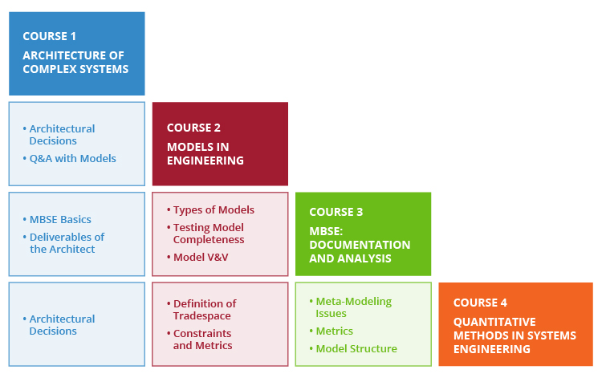

### **Learning Objectives**

#### Course 1: Architecture of Complex Systems

By the end of this course you should be able to:

* + 1. Motivate the need for system architecture by articulating the ideas of minimized rework and by offering examples of complexity in modern systems.
    2. Contrast several definitions of system architecture and construct a personal definition from your career examples.
    3. Differentiate systems thinking from other kinds of "thinking;" define a system, and articulate examples of things that are and are not systems. Apply system thinking to provide a perspective on a given project.
    4. Describe the architecture of systems and identify both architectural decisions and non-architectural decisions.
    5. Define and illustrate the system boundary and use it to identify system interfaces.
    6. Identify the constituent elements in architecture representations and place these in the context of the overall documentation of the system.
    7. Provide constructive criticism on the system architecture representations of others, including checking for completeness and consistency.
    8. Articulate more solution-neutral and less solution-neutral framings of a problem, and evaluate how solution-neutral to be for a given problem.
    9. Construct a design DSM, either by analyzing the design or by converting a graph of the system.
    10. Construct a process DSM and identify how it is different from a design DSM.
    11. Given a DSM, apply a sequencing algorithm to sort the components into modules or to sort tasks into groups.
    12. Describe rework and articulate the principles by which an analysis of change propagation could be conducted from a database of changes.
    13. Define the role of the architect and the stakeholders with whom the architect should work.
    14. Define the deliverables of the architect, with references to architecture frameworks and your career examples.

#### Course 2: Models in Engineering

By the end of this course you should be able to:

* + 1. Explain what types of models exist in engineering and how they can be organized into an overall taxonomy.
    2. Enumerate the purposes for which models are created in engineering and evaluate the success of modeling for those purposes against your own career experience.
    3. Describe a potential model development process, leading to models of increasing levels of fidelity.
    4. Demonstrate through examples how models are used to make decisions in engineering and how models can be used for optimization, including the definition of design variables, fixed parameters, objective functions, and constraints.
    5. Evaluate the credibility and fidelity of existing models using a set of clear criteria.
    6. Evaluate and explain whether it is better to pursue a single model or an ensemble of models in support of a specific problem/decision. This includes the resolution of conflicts when multiple models provide contradictory results.
    7. Explain the basic principles of combining subsystem models together into a system model in a multidisciplinary computational environment.
    8. Understand the basic principles of verifying and validating models.
    9. Examine the tradeoffs between the use of physical and virtual prototypes for system verification, validation, and testing. Decide when to invest in additional modeling versus additional physical testing of systems.

#### Course 3: Models -Based Systems Engineering

By the end of this course you should be able to:

* + - 1. Identify the core tenets of MBSE and the situations in which it is recommended
      2. Distinguish the differences between MBSE and traditional systems engineering
      3. Choose an appropriate scope, define the purpose, and define the approach for an MBSE project
      4. Describe the intent and basic structure of SysML, and interpret a simple SysML model
      5. Critique a project’s implementation of MBSE using a set of criteria
      6. Build a model management plan
      7. Reference existing industry examples of MBSE to anchor choices about the scope of MBSE to undertake, and communicate potential approaches using industry examples as signposts.

#### Course 4: Quantitative Methods in System Engineering

By the end of this course you should be able to:

* + - 1. Define the criteria and decisions to be answered with tradeoff analysis
      2. Evaluate and select alternative concepts
      3. Understand how, when, and why trade studies are conducted
      4. Identify multiple cost and benefit criteria that frame a system decision opportunity
      5. Construct a stakeholder value hierarchy to inform system design decisions
      6. Populate a value model
      7. Understand core concepts of value-focused thinking
      8. Generate a design space
      9. Apply a cost model to support design decisions
      10. Apply a performance model to evaluate a system (and/or its components)
      11. Apply a value model to support design decisions
      12. Choose relevant axes and representations for a tradespace
      13. Interpret the results of a tradespace
      14. Determine preferred system alternative(s) from a set
      15. Identify the Fuzzy Pareto Front in a tradespace
      16. Perform a sensitivity analysis
      17. Critique a decision analysis by identifying sources of uncertainty, variation, and dynamic subjectivity, and describe how they affect outcomes
      18. Understand some of the human aspects of using methods and models.

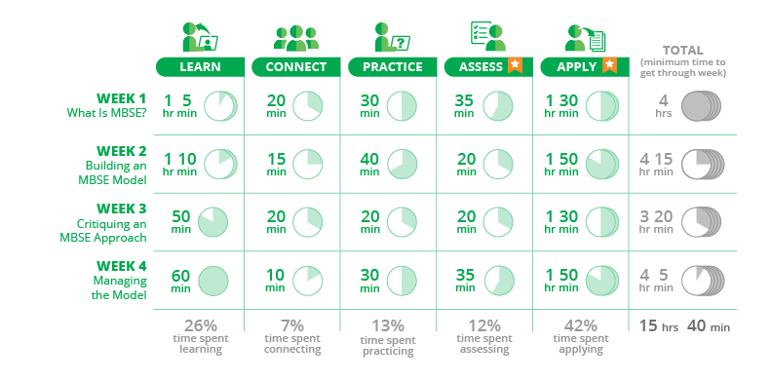

1:11 / 4:31

Press UP to enter the speed menu then use the UP and DOWN arrow keys to navigate the different speeds, then press ENTER to change to the selected speed.

Click on this button to mute or unmute this video or press UP or DOWN buttons to increase or decrease volume level.

Maximum Volume.

### Video transcript

1. [Start of transcript. Skip to the end.](https://mitprofessionalx.mit.edu/courses/course-v1:MITxPRO+SysEngxDEMO+2T2017/courseware/e027d7c1fe904d969897660e5a288de7/0cc969f443a44bc68a57a134001eb22b/?child=first#transcript-end-ceb4f4a07cfa405583cc92f7345286eb)
2. I would like to discuss a taxonomy of models with you.
3. Models are essential in systems engineering
4. to help us make better design decisions,
5. to optimize our designs, or to just
6. share what a particular system looks like
7. and how it will operate in the future.
8. So what we mean by model is not the actual system, but are of,
9. typically, a mathematical construct
10. that has the ability to predict the behavior of a real system
11. under a set of defined operating conditions,
12. and usually a set of simplified assumptions that are often
13. hidden, but they should be explicit.
14. The simulation is, then, a process that takes a model
15. and instantiates it for a particular set of operating
16. conditions, initial conditions, with the goal of predicting
17. the future behavior of the system.
18. So to keep these two terms apart that are often
19. used synonymously-- the model is a construct that contains
20. mathematical relationships that have the ability
21. to predict future behavior.
22. And the simulation takes the model,
23. instantiates it, and actually executes the simulation
24. for prediction of future behavior.

# What is MSBE, and the benefts?

Solution to document based engineering

(Merge Visio, excel, word), etc.

digital models of systems – capture function, structure interfaces and future behavior.

**Based on shared system model**

System

Subsystem

Component

we understand who all will be impacted by that change before we actually go solidify that change decision.

**capturing requirements** and linking your design in a model to those requirements.

traceability from the user's expressed desires of a certain functionality or a feature, down to the actual component that manifests the result of that requirement, all the way back through its verification, validation, and integration as a complete system.

Can consistency check all of my requirements

model these interactions,

model the interfaces.

see where you've got seams in your data,

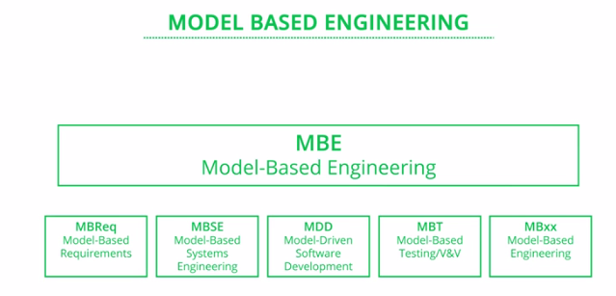

"MBSE" is "model-based systems engineering." - application of models

"MDD," "model-driven development," which is the application of models to software

development-- where we develop models of the software and then even generate the running software code right out of those models.

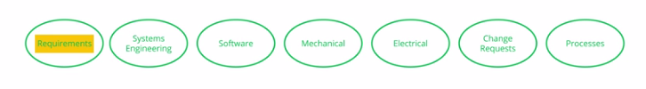

Sort of like a system-of-systems, it's a model-of-models.

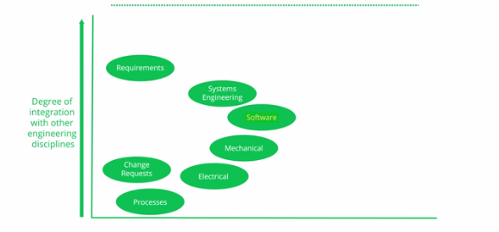

- communicate better with other engineering disciplines and produce more unified designs.

- integrate engineering information across the lifecycle, enabling us to do things like searching and navigating and tying and tracing information together

- simulate designs.

**- to reuse information so** that, as the engineering

- So models then become the way we do engineering, not

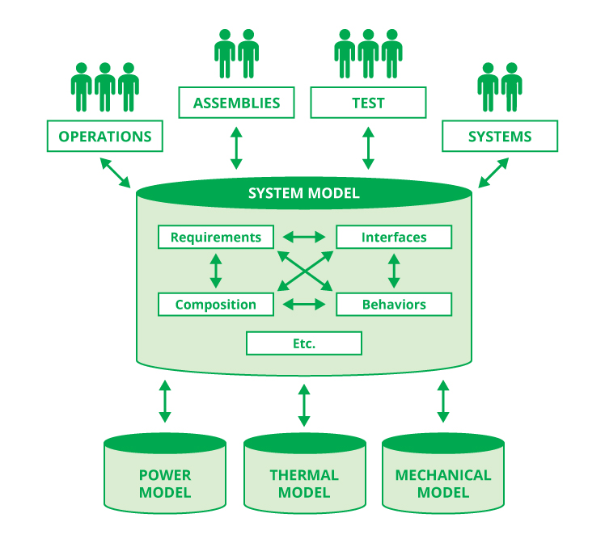

System Model - IBM Rational DOORS.

Master equipment list – product and non-product (test equipment)

ConOps,

operational view diagrams,

interface description documents, design structure

matrices, test scenarios, specifications,

For our example satellite system, we have four types of interfaces defined:

**mechanical,** - physical envelopes – clearance , surface s and hardware for mounting, bolt hole pattern

**thermal** – heat transfer method, thermal path – specifys magnitude of load and flux, operating temperatures are, and what are the extreme environmental conditions that each interface can handle.

**power,**

There also need to be specifications for the formats of CAD models or finite element analysis models.

System block diagram:

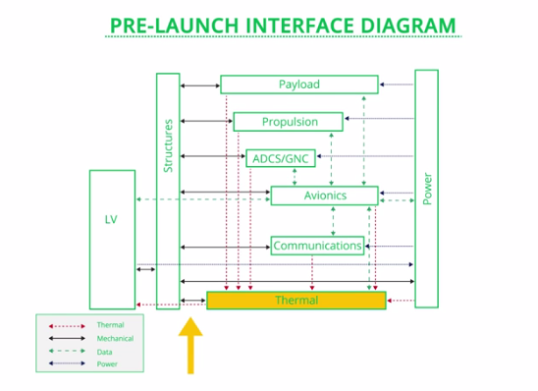

You also want to break it up by the operational phase. And that's because, the **programmatic and technical interfaces might change.**

There is an interface control diagram for all lines

Bi-directional exchange of data

Passes through – data wire , powerline or thermal pathway

Abstraction and eliminate redundancy while still providing the same level of detail.

**Communications**

Living document – model

Verify –

Complete – enough information without questions 3-4 levels of details

No contradictions

Clear

Consistent - It is hard to verify consistency of information in a document-based approach

Elegant model – not ugly

I'd rather draw boxes and circles and start to connect them with lines, with arrows.

Diagramming is really informal model-based systems engineering.

One of the benefits of model-based systems engineering is that you don't only model the sunny day scenario –nimal model (20% of the decision)

80% - contingencies or worst case scenarios

**Nominal model** covers the basic outcomes from the system without going into detail about the contingencies and emergency conditions.

**Cyber-physical gaps** are the difference between what is happening in real life and what people get as input from systems, or what people perceive is happening in the real world.

**MSBE as language, abstraction and Automation**

Systems engineering is a vast discipline and it's hard to list out all its objectives, but at its heart lie two key tasks (Jenkins, 2016):

**1. Facilitate Collaboration**

a. Delegation of decomposed design problems

b. Integration of peer components into systems

**2. Employ Analysis**

a. Predicting behavior from design, including programmatic metrics (cost, schedule, etc)

b. Synthesizing design from desired behavior

MBSE has three tools that can be used to address the tasks above: **language**, **abstraction**, and **automation** (Jenkins, 2016).

Language - common vocabulary and structure that helps us effectively communicate ideas and decisions (Systems Modeling Language (SysML)

Abstraction - helps cut the noise and brings out the most relevant information about the system; The model is never a complete representation of the system

Automation - uses computation power to perform simulations that provide additional information about the system

**Philosophy**

Models are the house of information.

Model-based engineering also implies a seamless, continuous flow of information,

It's about an ever-evolving set of information

enabling us to build a shared understanding

be able to automate as much as possible.

what makes a model a model

-It had formulas and references and calculations that **tied the information together** in the spreadsheet so that any time I changed one bit of information

-intelligent relationships between elements.

They're tied together in a

mathematical way,

in a logical way,

tied together with semantic richness,

**Model-based Philosophy I**

use to document something

represent things

communicate with others

calculate

build things

act a shared mental product

**So I might express a model in a**

high-level language, like SysML, and then I might

express the fulfillment of that in, say, a 3D CAD model

Dangers in this philosophy

**- all models are good.**

- we do modeling just because **some method tells us to do modeling**, right. We become slaves to the methodology.

- doing **documentation models exclusively**. If the only kind of modeling we're doing

is afterthought modeling, right, modeling that expresses things that are already thought out, then that's a negative pattern as well.

<https://mediaex-server.larc.nasa.gov/Academy/Play/804f524f16c24fd2927a4eb9f01bdf831d>

**(Introduction to model-based systems engineering)**

**Major Tenants of MBSE**

a **central model or a federation of models** is centrally used to represent the design.

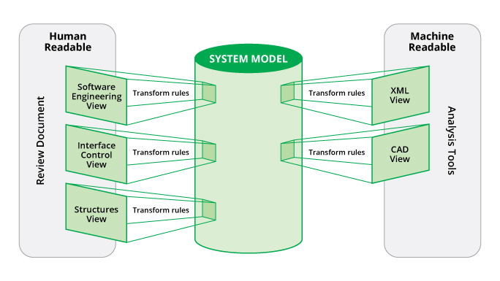

Image Courtesy of NASA / JPL-Caltech

**Model repository** - the ability to reuse parts of the model from past projects

**Standards and patterns** define a set of rules, best practices, and processes that create structure in the design environment.

**Model Checking: Logically Verifiable Rules or Tests**

operating constraints at the components level such as the maximum RPM allowable for the crankshaft.

apply some logical restrictions on the interactions of various components.

**Ontology -** describes a set of concepts in a domain with definitions, properties, and relationships between the concepts

historical vocabulary to describe systems such as  requirement, verification, configuration item, etc.

notions of composition, for example: part➔ subassembly  ➔ assembly ➔  subsystem ➔ system

**Process (P)**: a logical sequence that defines the tasks needed to performed to get the desired output. In other words, it defines WHAT needs to be done.

**Method (M)**: a technique for performing a task. In other words, it defines HOW each task needs to be performed.

Customizable processes – set of tasks

Standard or customizable methods for tasks

# **Purpose of MBSE\***

There are many potential benefits that have been postulated for MBSE. Some of the benefits have been collected below. These benefits should help describe when the project is done - serving as completion criteria for the project, so the scope does not extend to modeling everything in great detail for the sake of modeling. It is important to note that relatively few full projects have been completed using a full MBSE approach, and therefore data on the realization of these benefits is sparse.

Similarly, data on the investment required to pursue an MBSE approach are rarely available. The investment should consider new capabilities that must be hired, spending on software tools and customization of those tools, training effort, model building and maintenance effort, among many others. Experience suggests that the investment is significantly weighted towards the front of a program. These benefits must be weighed against the investment required, to determine the feasibility of the approach.

**Enhances Communication**

* + - A single authoritative source of information helps keep all the teams on the same page and promotes effective communication.
    - Each team consumes information in the format they understand.
    - It reduces the chances of having stale information, by using proper configuration management.
    - Allows various teams to work in parallel by providing effective information communication between teams.

**Improves Productivity**

* + - It helps perform simulations to test and iterate various concepts quickly at an early stage, thereby increasing the overall productivity and providing better end outcomes.
    - It makes it easier to generate the time-consuming project documents and reports.
    - Allows various teams to work in parallel by providing effective information communication between teams.

**Improves Quality**

* + - Detects and highlights inconsistencies early in the design process because of clear semantics.
    - It enables verification and validation based on the requirements at each successive design increment.
    - Documents generated from the model are always up to date.

**Supports Integration**

* + - MBSE should provide consistent definitions of interfaces to help different models to talk to one another.

**Manages Complexity**

* + - By allowing teams to quickly test and compare hundreds of different design options, making it easier to make the best decisions.
    - Provides different views into the system that address the needs of different stakeholders from the same information.

**Facilitates Reusability**

* + - By creating a modular structure, it allow for models (or parts of models) to be reused for other projects.

# Several proposed **methodologies for MBSE** include:

[Object-Oriented Systems Engineering Methods (OOSEM)](http://www.omgwiki.org/MBSE/doku.php?id=mbse:incoseoosem)  OOSEM uses SysML to support the analysis, specification, design, and verification of systems. It was developed in 1998 and further evolved as part of a joint effort between Lockheed Martin Corporation and the Systems and Software Consortium (SSCI), and was further refined by the INCOSE OOSEM Working Group beginning in 2002

IBM Rational Unified Process for Systems Engineering (RUP SE) for Model Driven Systems Development

Vitech Model-Based System Engineering (MBSE) Methodology

model elements in terms of business objects that correspond with typical systems engineering concepts:

1) requirements,

2) behavior,

3) structure and interfaces,

4) verification, and

5) other life cycle features

(Start - [http://www.omgsysml.org/MBSE_Methodology_Survey_RevB.pdf)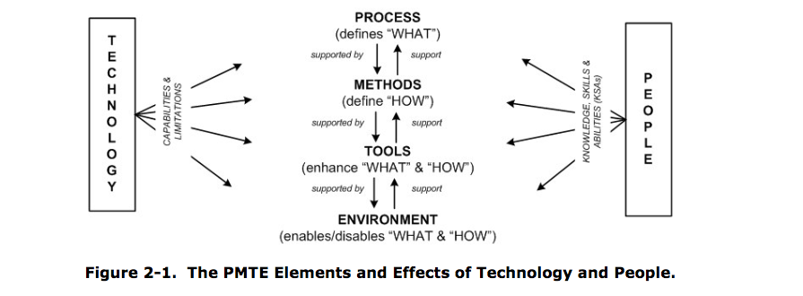](http://www.omgsysml.org/MBSE_Methodology_Survey_RevB.pdf))

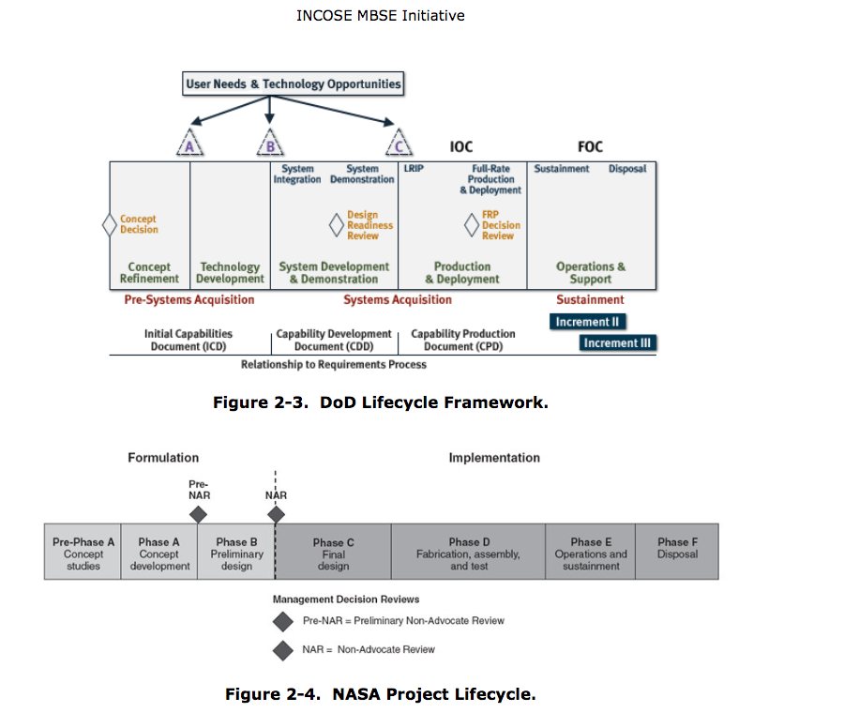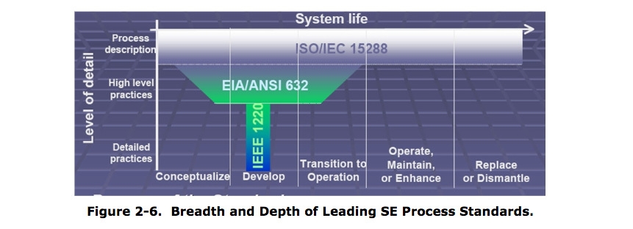

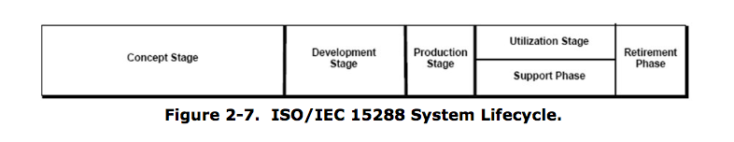

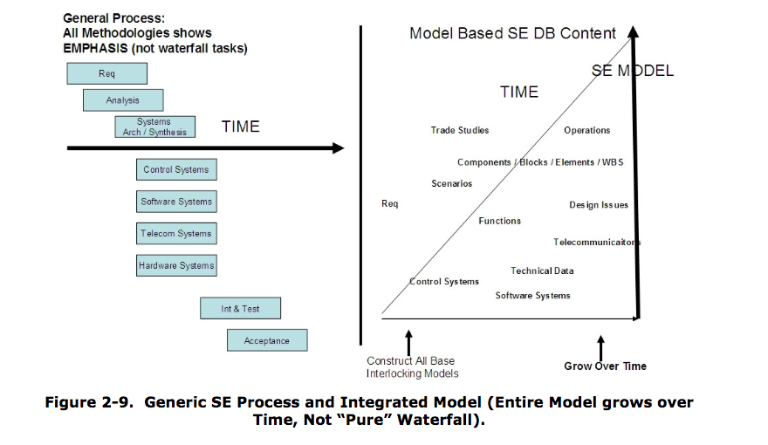

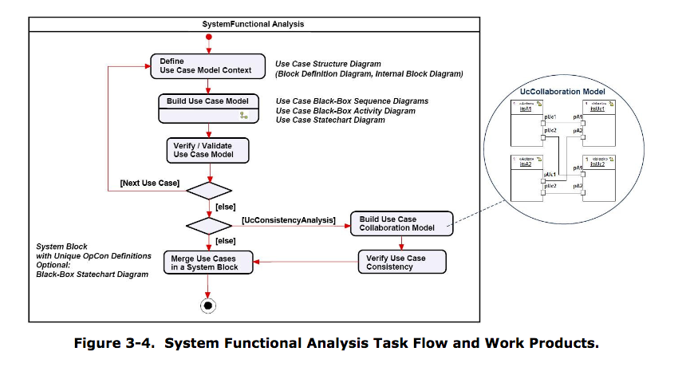

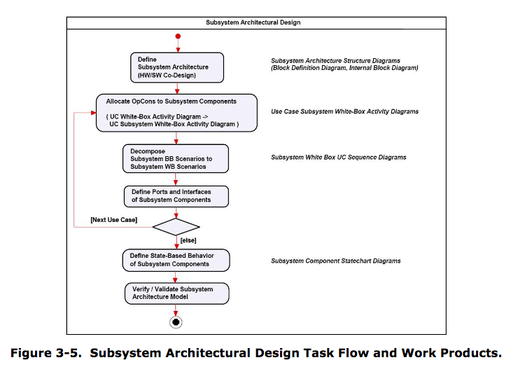

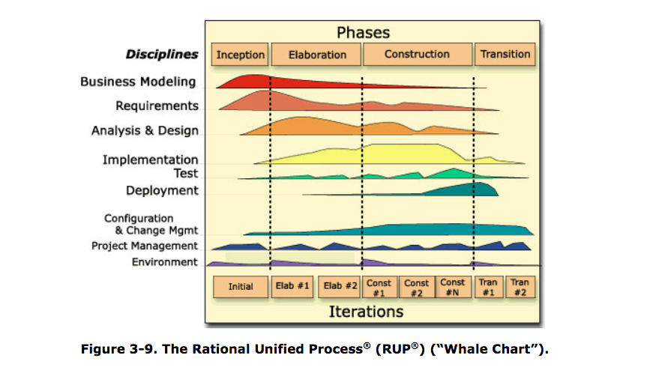

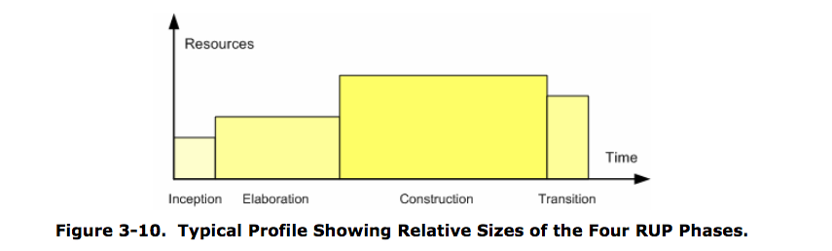

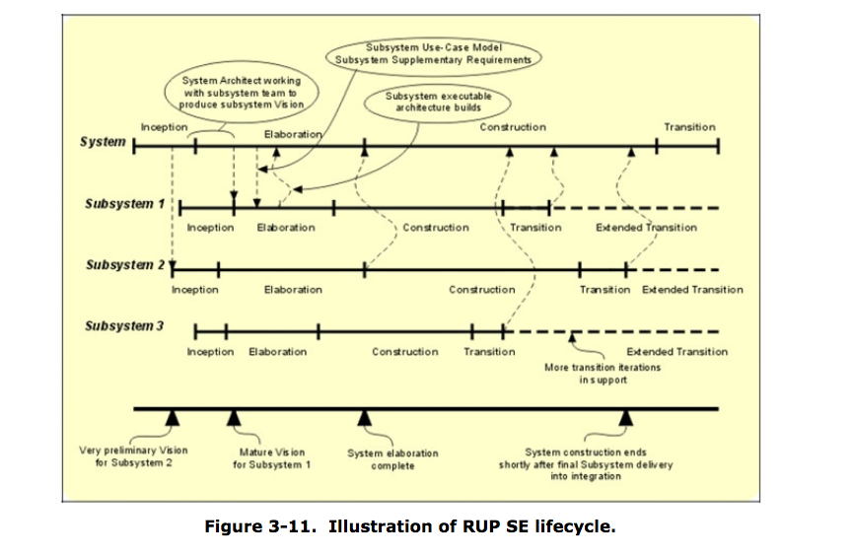

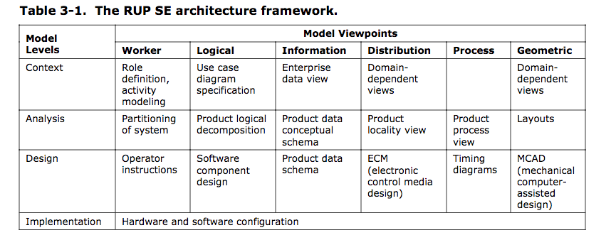

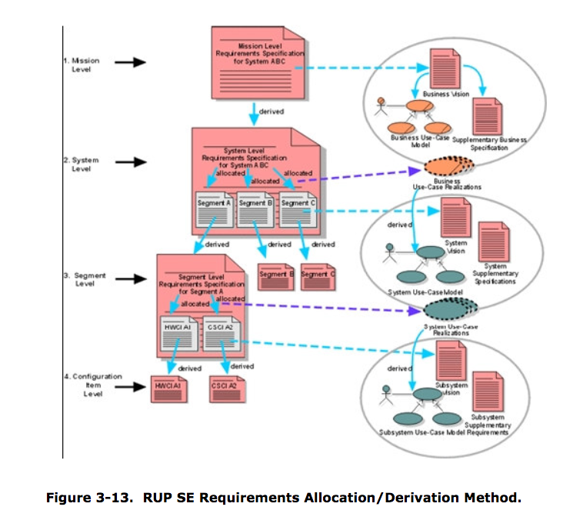

Tool:

RUP SE plugin for the Rational Method Composer (RMC) product offering from IBM Rational®software. At the time of this writing, RUP SE V3.0 is included as part of RMC V7.2. A complete list of RMC plugins can be found at: http://www.ibm.com/developerworks/rational/downloads/07/rmc_v7.2

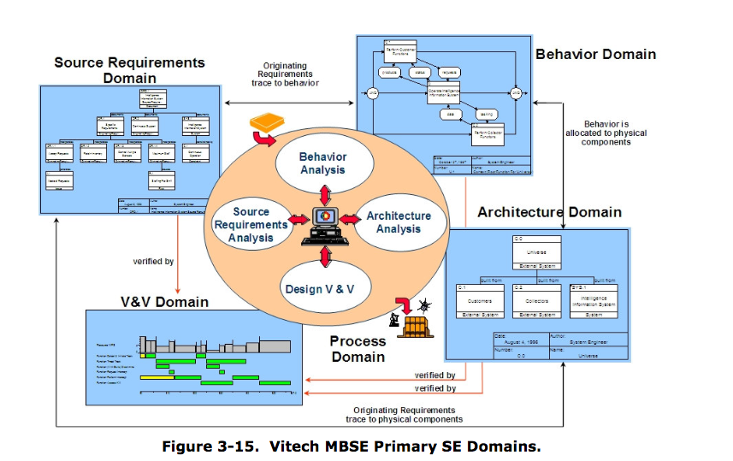

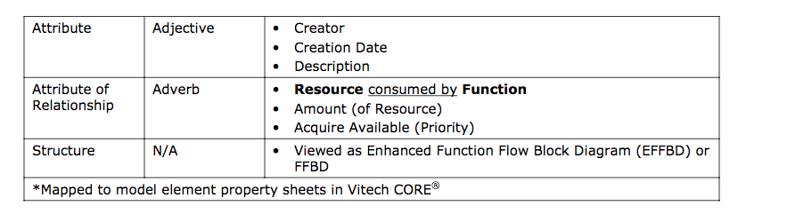

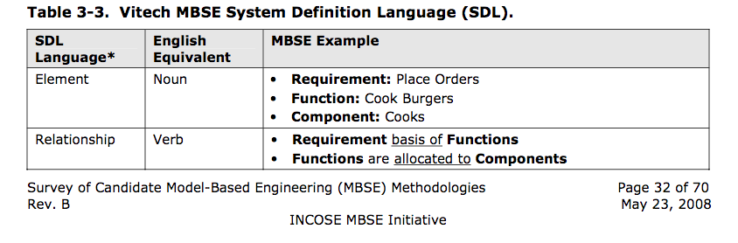

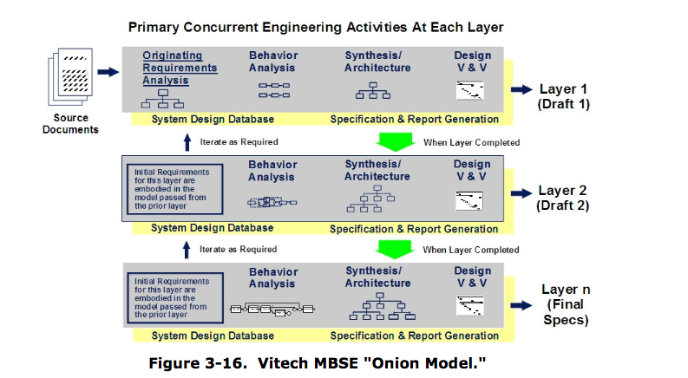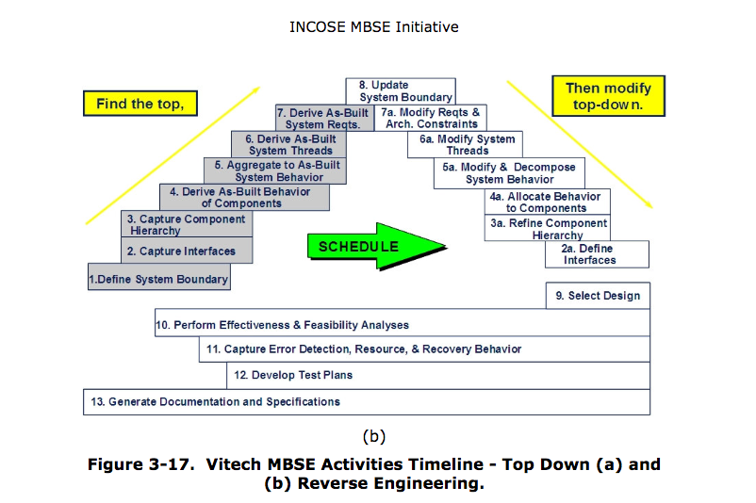

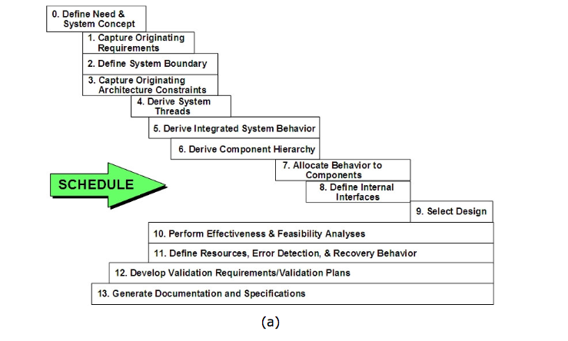

JPL



**State is explicit**

. The full knowledge of the state of the system und

er control is represented in a collection of state variables.

**State estimation is separate from state control**

. Estimation and control are coupled only through state variables. Keeping these two tasks separate promotes objective assessment of system state, ensures consistent use of state across the system, simplifies the design, promotes modularity, and facilitates implementation in software.

**Hardware adapters provide the sole interface between the system under control and the control system**

. They form the boundary of the state architecture, provide all the measurement and command abstractions used for control and estimation, and are responsible for translating and managing raw hardware input and output.

**Models are ubiquitous throughout the architecture**

. Models are used both for the execution (estimating and controlling state) and higher-level planning (e.g., resource management). SA requires that the models be documented explicitly, in whatever form is most convenient for the given application.

**The architecture emphasizes goal-directed closed-loop operation**

. Instead of specifying desired behavior in terms of low-level open-loop commands, SA uses goals

, which are constraints on state variables over a time interval.

The architecture provides a straightforward mapping into software

. The control diamond elements can be mapped directly into components in a modular software architecture, such as Mission Data System (MDS).

13

SA provides

a methodical and rigorous approach for the following three primary activities:

**1.State-based behavioral modeling.** Modeling behavior in terms of system state variables and the relationships between them.

**2.State-based software design**

. Describing the methods by which objectives will be achieved.

3**.Goal-directed operations engineering**

. Capturing mission objectives in detailed

scenarios motivated by operator intent.

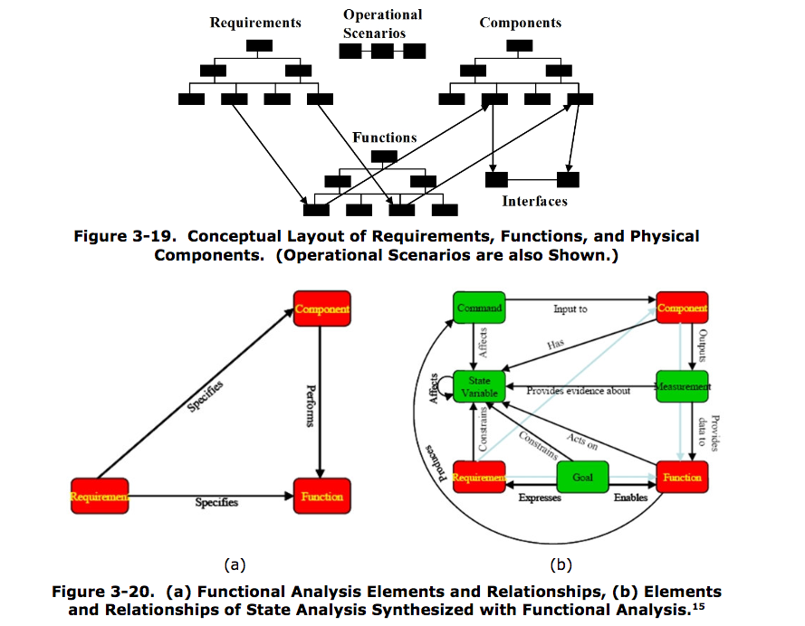

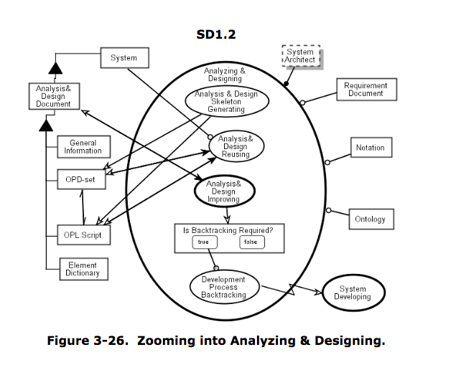

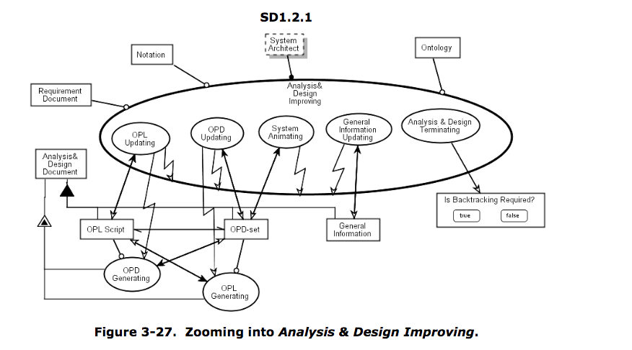

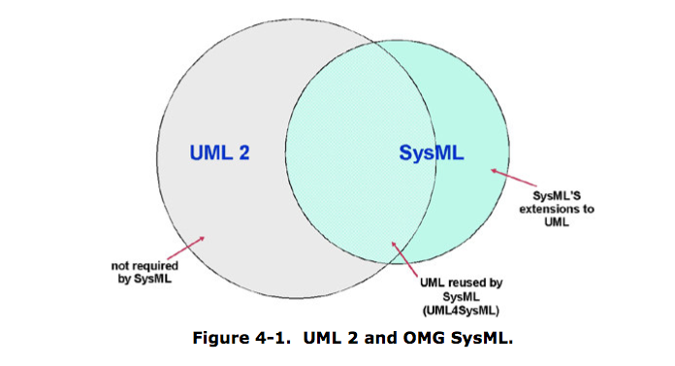

http://www.uml.org/

<http://www.omgsysml.org/>

(end) <http://www.omgsysml.org/MBSE_Methodology_Survey_RevB.pdf>

# Qualities of great models

|  |  |
| --- | --- |
| **Category** | **Quality** |
| Decisions | **Linked to Decision Support:** The real value of models lies in using them in the **decision-making process**, particularly where we have to **trade-off between a lot of parameters**. The best models make evident how their outputs are to be used in decision-making. |
| **Model Credibility:** Credibility refers to whether the results of the model are believed by decision makers. If models are not credible, decision makers will not make decisions based on the model's output, which might waste precious time and resources, or worse still, they may make incorrect decisions that could put the project at risk. There are many ways in which to build model credibility -- one of which is having a set of standards and processes that guide the evaluation and validation of the model. |
| Scope | **Clear Scope:** Particularly for complex systems, modeling the entire system may not be needed for the project. The breadth must be agreed upon at the beginning of the effort: Which system or part thereof will be modeled. For example, in the automobile industry, the initial design iteration may model all of the components of an engine (broad modeling), while other efforts may work with stable interfaces and model only one component (narrow modeling). |
| **Verification & Validation With Models:** If the model is being used to verify and validate a product / process / business, that model should clearly showcase how modeling is the preferred V&V route for the task. A single model should never be the only V&V tool. |
| Usability | **Understandable and Well–Organized:** More than just documented, is it evident where and how you would add to the model? A Model Development Process can lead you to a modularization and organization of the model that is more understandable. |
| **Analyzable and Traceable:** Great models are easily queried. Further, they make it easy to identify what variables or sections of the model contributed to the answer. For example, if the computed thickness of a beam is 6mm, which load cases made the greatest demands on the thickness? |
| **Data Extrapolation:** Models are only intended to work over a limited range of data, conditions, physics, and assumptions. Great models describe clearly where they are valid, and where they are not valid. |
| Qualities | **Complete Relative to Scope and Intended Purpose:** The model does not leave out any important physics or dynamics. For example, a model of the economy that includes stock prices but excludes bond prices would be incomplete. |
| **Internally Consistent:** The model does not contain any direct contradictions. For example, assumptions on the gravity constant in one section are the same in all sections of the model. |
| **Verifiable:** The model itself must be verifiable. If the outputs of the model cannot be identified as meeting the modeling needs or matching the calibration data, then the model’s credibility for decision-making will suffer. |
| **Validation:** The model itself must meet customer needs and expectations. If the model is primarily descriptive, it must be capable of effectively describing the information contained therein, often by layering / delayering information presented. If the model is analytical, it must be shown to improve the decision-making for which it was created. |
| Implementation | **Model Fidelity:** The model should have the appropriate level of fidelity relative to the decision under consideration and the phase of the design. More fidelity than necessary can make it difficult to evaluate the model and can waste resources which could have been utilized elsewhere. Less fidelity than necessary can result in poor decisions or overconfidence. The choice of fidelity depends upon the system requirements and operating conditions. |
| **Elegant:** Is the model built using an economy of description -- as simple as possible but no simpler? For example, a model that pulled data from a table and calculated the same parameters from the same data repeatedly might be considered inelegant -- could the result of the computation be stored then reused? |
| **Well Formed for Optimization:** Has the model been constructed to facilitate optimization if necessary? Does it expose relevant optimization information, like gradients or convexity? |
| **Avoid Optimizing on a Black Box:** If two models are combined, one of which attempts to optimize the other, note that optimization performs more poorly on "black box" models, where features of the “black box” model are not evident or cannot be taken advantage of by the optimization routine. Where possible, optimization should be written to take advantage of model structure and features. |
| Interchange | **Availability of Interfaces:** Great models should have accessible interfaces to the underlying data and outputs |
| **Reusable:** Models should be created in a way that makes them reusable beyond the initial system or situation for which they were created. One way to accomplish this is to choose a modular model structure and to avoid hard coding parameters into the model. By reusing models across different projects, an organization can create new products faster and with less cost. However, model reuse can also introduce risks if the reuse happens outside of the intended or validated range of applicability. |

<http://www.omgsysml.org/MBSE_Methodology_Survey_RevB.pdf>

**Building a MBSE Model**

# Languages and programs

Change/vision Astah SysML

ConceptDraw SysML Solution

Dusan ROdina Software Ideas Modeler

Esterel Technologies SCADE System

IBM Rational Rhapsody

Lattix Architect

Modeliosoft Modelio

No Magic Cameo Systems Modeler

Object Management Group (OMG) Visual Paradigm for UML

OPCAT

Papyrus

PolarSys Capella

PolarSys Topcased

PTC Integrity Modeler

Sparx Systems Enterprise Architect

SPEC Innovations Innoslate

SysML Designer

Vitech CORE

Vitech GENESYS

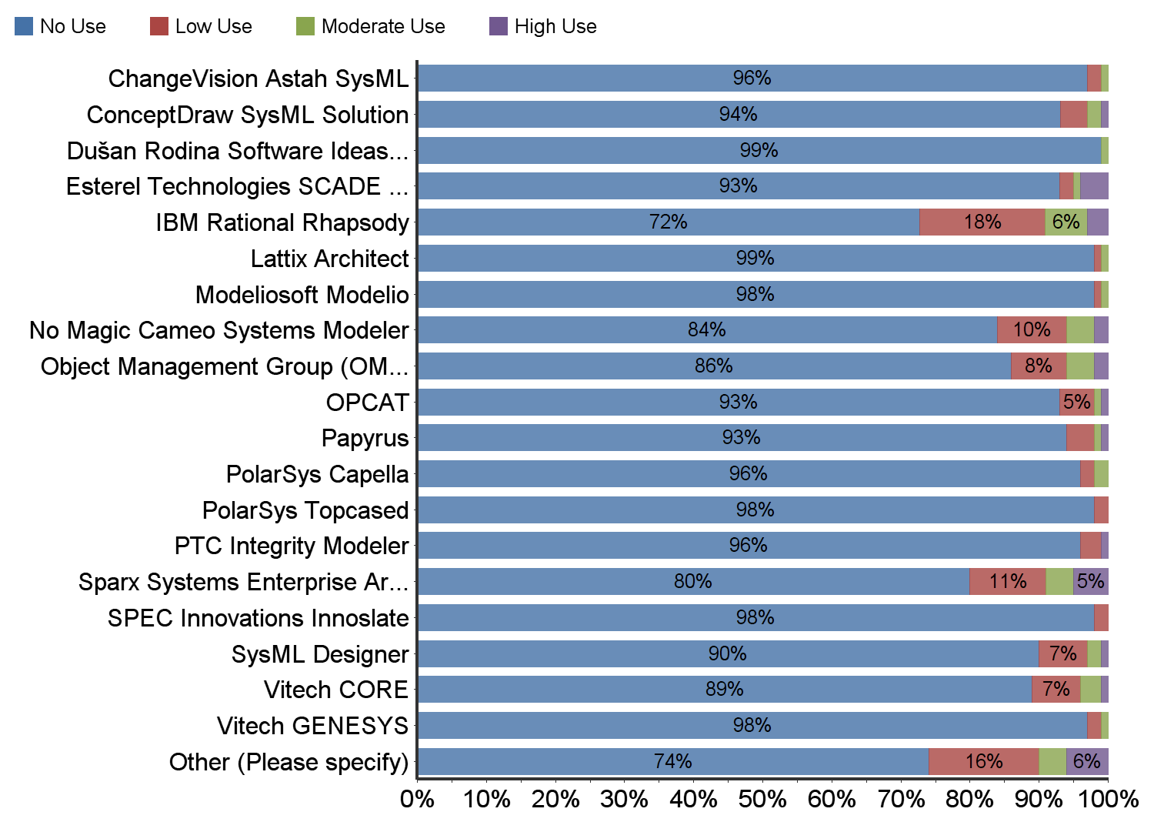

Conceptual design -> implementation & operations

Encode data into a model – documents aren’t data

Queried for errors and omissions

SySML Diagrams and syntax

Spec for

System

Subsystem

Component

Completeness and accuracy

Traceability be displayed

Consistency across docs (same parameter naming convention)

Share model to communicate data

An**interface control document** (ICD) in systems engineering describes the interface or interfaces between the systems under consideration. The purpose of the ICD is to communicate all possible inputs to and all potential outputs from a system for some potential or actual user of the system.

**Requirement traceability** is a discipline concerned with documenting the requirements and providing bi-directional traceability between various associated requirements through the life of the product.

The **change management process** in systems engineering is the process of requesting, planning, implementing, and evaluating changes to a system while supporting the processing and traceability of changes.

3% primarily model-based

# Entity Model configuration example

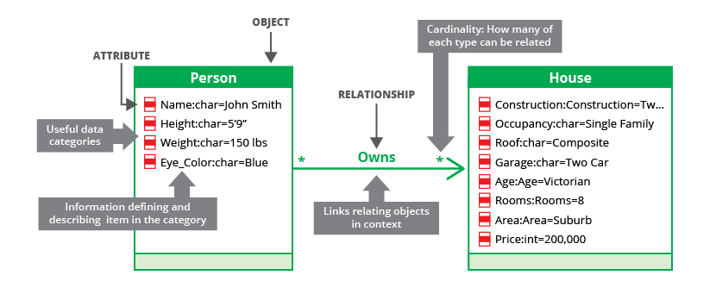

class <----------> usage data <------------> demo data

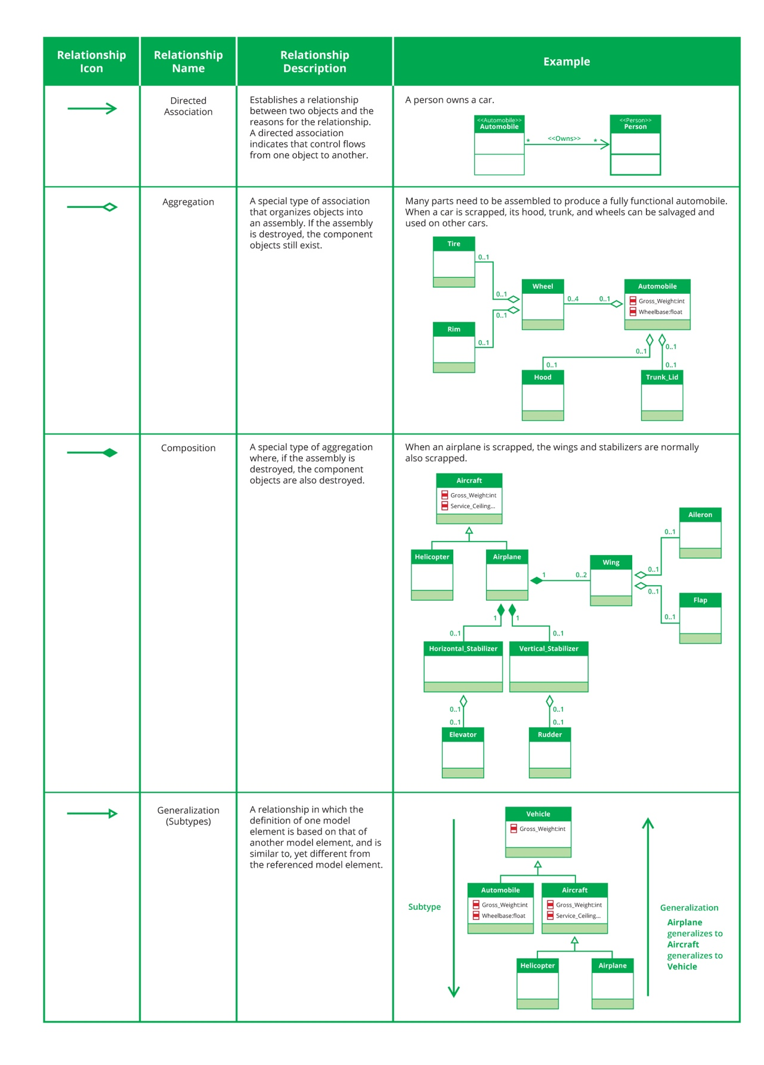

Cardinality

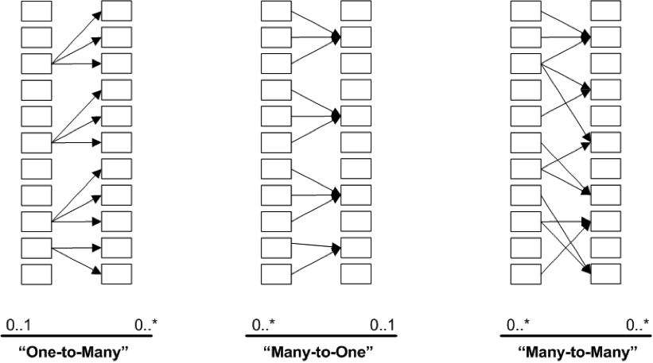

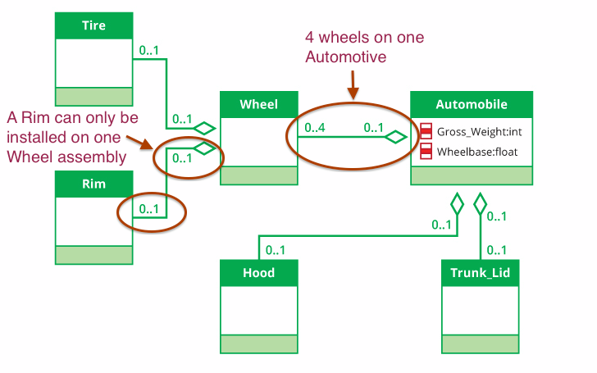

Entity class – entities grouped by type

1:1

1:many

many:many

Queries

Are all functions have a home responsible for executing

Search process

Based on constraints

Eg. Through a database

If …then row by row

Systems engineer

Any components not assigned

Any functions with no assignment

All the things that have changed

# Overview of SySML



Express the complexity of systems

Reduce ambiguity of systems

Express designs so they could be implement

So they could be simulated

UML –SW architecture

From UML

Activity diagrams

Block diagram

Packages

Sequence diagrams

State machines

Use cases

SySML added

Parametric constraint

Requirements diagrams

Independent of engineering

# SML Diagrams

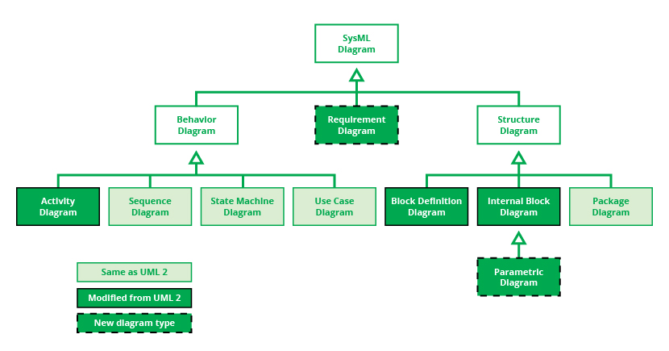

Behavior – operation, flows, use-cases

Structure – architecture, major sub, how relate and depend on each other

Requirements diagram

# Four pillars:

Structure

Behavior

Requirements diagram – holistic view of the system model

Parametric – numeric quantity and performance of systems

|  |  |  |
| --- | --- | --- |
| **Diagram Type** | **Abbr.** | **Description** |
| [Activity Diagram](https://www.threesl.com/cradle/help/System%20Modelling/other/act.htm) | act | A SysML activity diagram is like a flowchart that describes the flow of control and data as the system executes its function. It is primarily used to define the behavior of a component  in terms of the time ordered sequence of actions to be executed based on the availability of inputs, outputs and control logic, and how the actions transform the inputs to outputs. |
| [Block Definition Diagram](https://www.threesl.com/cradle/help/System%20Modelling/other/bdd.htm) | bdd | A SysML block definition diagram is the primary kind of diagram you create to communicate structural information about a system and shows component parts (i.e. blocks) that should exist in the system across different levels in hierarchy. It also depicts relevant properties and interfaces of each component part. |
| [Internal Block Diagram](https://www.threesl.com/cradle/help/System%20Modelling/other/ibd.htm) | ibd | A SysML internal block diagram describes the internal structure of a block, its properties, and connectors. It defines the interconnections of the block's component parts and the interactions (i.e. interface information) between the parts and between the parts and the systems outside the model boundary. |
| [Package Diagram](https://www.threesl.com/cradle/help/System%20Modelling/other/pkg.htm) | pkg | A SysML package diagram allows you to organize models by partitioning model elements into packageable elements and establishing dependencies between packages, and/or model elements within packages. A package is like a container for anything else in the model. A hierarchy of packages can be defined. |
| [Parametric Diagram](https://www.threesl.com/cradle/help/System%20Modelling/other/par.htm) | par | A SysML parametric diagram illustrates system constraints such as one or more performance constraints, specifically equations and inequalities. It also supports engineering analyses, including performance, reliability, availability, power, mass, and cost. It can also be used to support trade studies of different system architectures. |
| [Requirement Diagram](https://www.threesl.com/cradle/help/System%20Modelling/other/req.htm) | req | A SysML requirement diagram is used to depict the requirements of the system. A graphical, tabular or tree structure format can be used to depict hierarchies of stakeholder needs, requirements and test cases or to depict an individual need/requirement/test case and its relationship to other model elements. |
| [Sequence Diagram](https://www.threesl.com/cradle/help/System%20Modelling/other/sd.htm) | sd | A SysML sequence diagram is used to specify the behavior of several interacting blocks in terms of a sequence of messages exchanged between those blocks. It shows how objects operate with one another and in what order (interactions arranged in time sequence). It can also be used to specify test cases. |
| [State Machine Diagram](https://www.threesl.com/cradle/help/System%20Modelling/other/stm.htm) | stm | A SysML state machine diagram is used to specify the behavior of a system in terms of its states and the transitions between states triggered by events and time. It shows a series of conditions which an object can take up over its lifespan, and the causes of the state changes. |
| [Use Case Diagram](https://www.threesl.com/cradle/help/System%20Modelling/other/uc.htm) | uc | A SysML use case diagram is used to define operations in terms of how a system might be used by external entities (i.e. actors) to accomplish a set of goals/missions. Each use case is associated with a set of operational scenarios describing the desired activities to be performed. A scenario can be defined using an activity diagram. Use case diagrams are used to present a graphical overview of the functionality of a system. |

Modeling Behavior

# Use case

|  |  |  |
| --- | --- | --- |
|  |  |  |
| use case | a sequence of operations  or a sequence of events that expresses  a needed goal of the system.  Actors can be a system  Rectangle  -use cases are ovals  (expressed as a verb phrase)  written flow of events | Series of steps  ../../Desktop/Screen%20Shot%202017-06-15%20at%2010.01.59%20 |

# Activity diagram

|  |  |  |
| --- | --- | --- |
| Activity diagram | Express flow of action through use-case  Decision  Scenarios  Swim lanes-shows responsibility of actions | ../../Desktop/Screen%20Shot%202017-06-15%20at%2010.04.17%20  ../../Desktop/Screen%20Shot%202017-06-15%20at%2010.04.10%20 |
|  | Could represent a component within the system | ../../Desktop/Screen%20Shot%202017-06-15%20at%2010.06.08%20 |

# Modeling behavior/state:

|  |  |  |
| --- | --- | --- |
| State-motivate the execution | State = turned-off, drive, park, reverse, accelerating, transitioning between different  Some beviours available from some states  i.e. turned-off-> can’t turn | ../../Desktop/Screen%20Shot%202017-06-15%20at%2010.06.08%20 |
|  | States: Choose fuel-> ready to pump-> stop pumping, continue pump, choose fule(no)  If the system is in this state,  1) what can I do from that state  2) What can I not do  Off(state)  Arm (exiting-time to get out of the door)  Active state  Substates:  Open door-entering state->time delay->no key->intrusiton state->key still okay | ../../Desktop/Screen%20Shot%202017-06-15%20at%2010.08.53%20  ../../Desktop/Screen%20Shot%202017-06-15%20at%2010.12.39%20 |

# Parametric diagram – math relationships

|  |  |  |
| --- | --- | --- |
| Parametric diagram | Allow to express math relationships between parts of system  Eg. Added <=  Indicate the relationships for the objective analysis of functions  Measure effectiveness  Support engineering analysis (e.g., performance, reliability)  Bind constraint usage to value properties of blocks (e.g., vehicle mass bound to F= m × a)  Parametric enable integration of engineering analysis with design models | ../../Desktop/Screen%20Shot%202017-06-15%20at%2010.16.28%20 |

Structure

# Block Definition, International Block Diagram

|  |  |  |
| --- | --- | --- |
|  | Block Definition Diagram (can have behavior)  **Block – system , part of system, ports**  Blocks-instantiations of blocks |  |

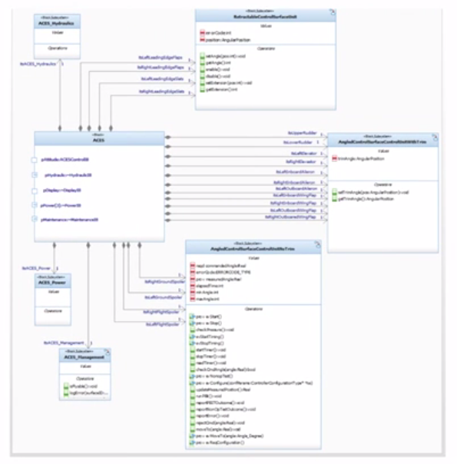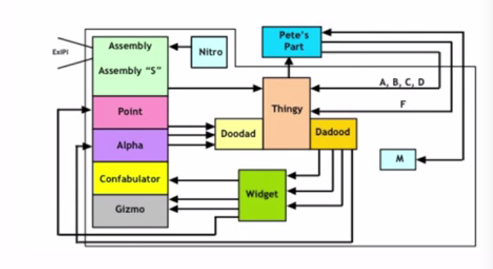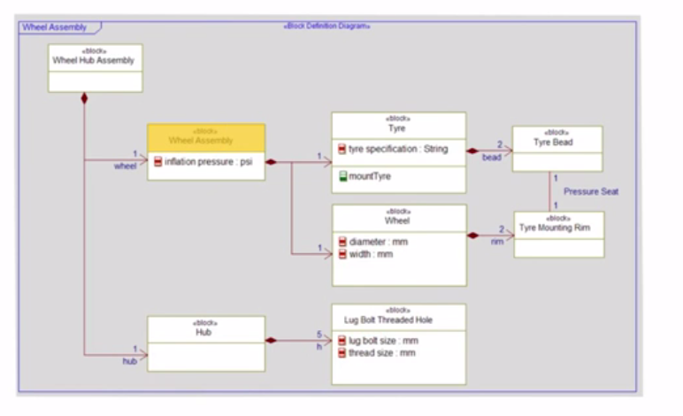

# Internal Block digram

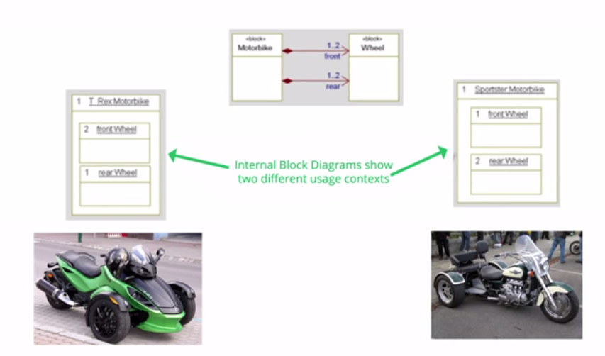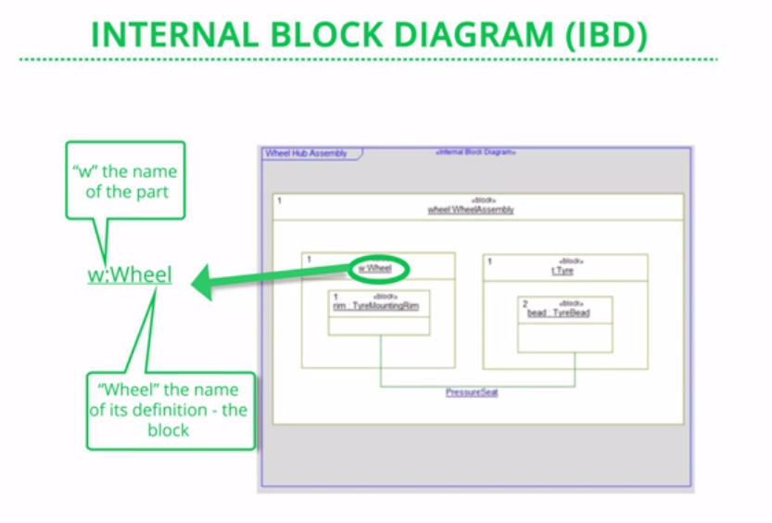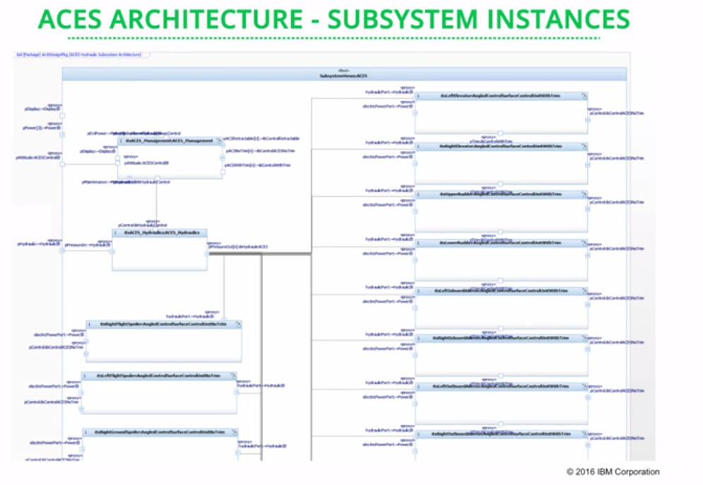

|  |  |  |
| --- | --- | --- |
| Ports=provides services | Named interface points between blocks |  |
|  | Standard port – name interaction point (this block has and provide or require some service)  Can be used for bus messages |  |
|  | Flow port = continuous flow of information | Services  Provided or = you can use this port (o symbol)  Required = ( “)” circle shape |
| Sequence diagrams | Represent how ports are being use | Blocks componetns of the system or actions  Vertical line = life line  Arrows=requests  Request = name on arrow |
| White box expansion of a sequence diagram |  |  |

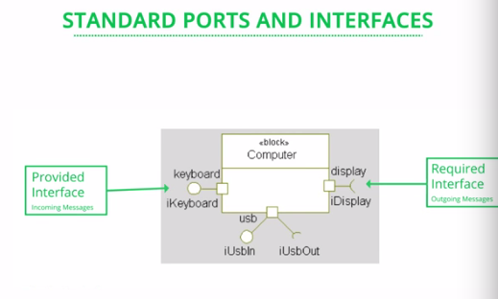

# Ports and Interfaces

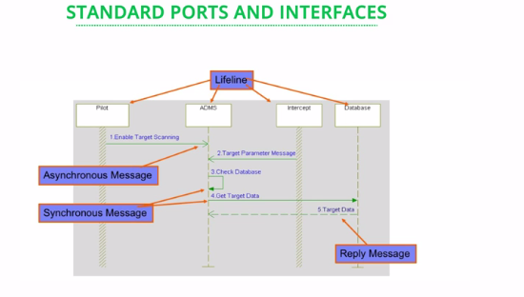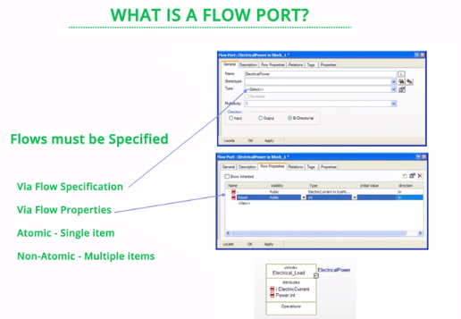

In this section you will use the example of a hybrid SUV (HSUV) to explore the diagram types. You will also examine the package and requirements diagrams in this section.

# **Package Diagram**

A model organization is essential to managing the model, and a package diagram helps with that.  A model can be organized in multiple ways, such as by:

Type of diagram (e.g., requirements, use cases, behavior, sequence)

System hierarchy (e.g., enterprise, system, subsystem, component)

Different viewpoints to augment model organization (might be team specific)

Sample package diagrams are shown below. Each package contains a set of model elements. The package is said to own the elements that are contained within it.

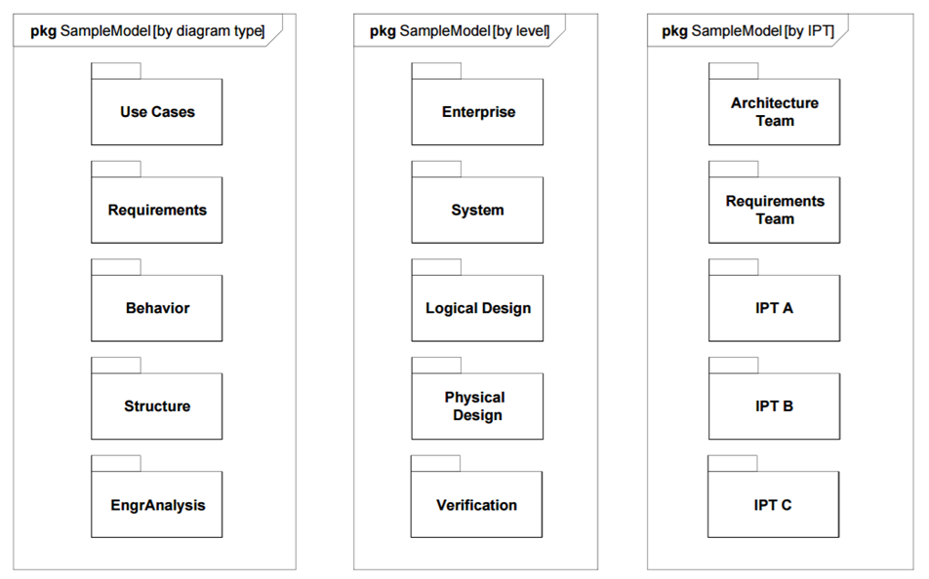

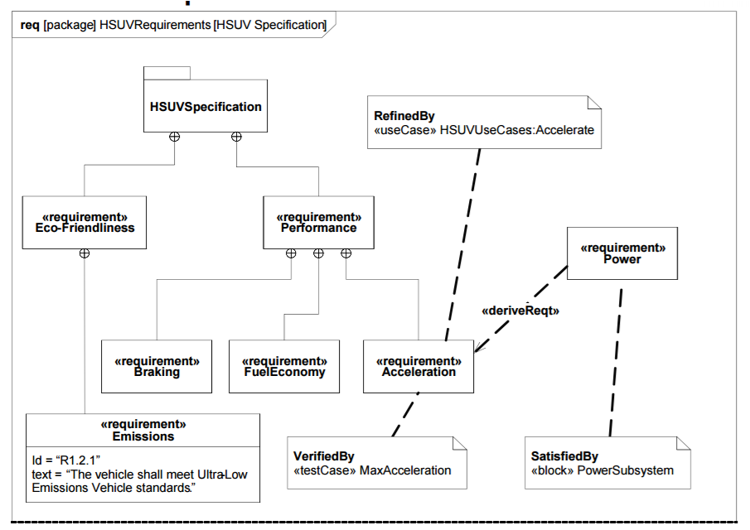

Sanford Friedenthal, Alan Moore and Rick Steiner. "OMG Systems Modeling Language Tutorial." 15 April 2008 <<http://www.omgsysml.org/INCOSE-OMGSysML-Tutorial-Final-090901.pdf>>

# Use case diagram

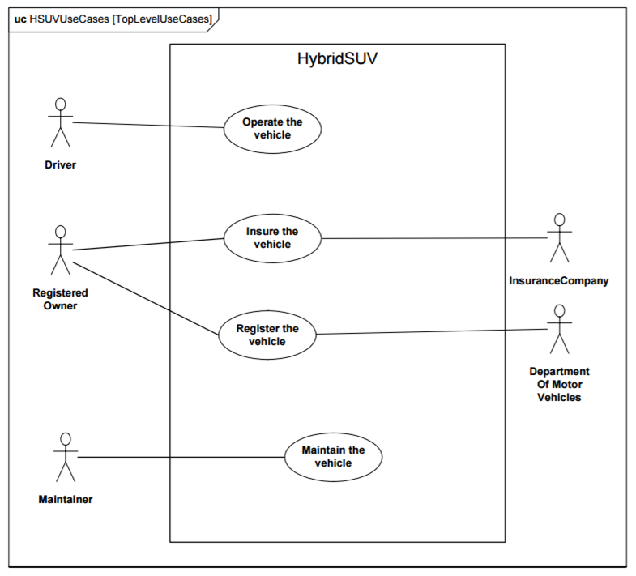

Object Management Group. "OMG Systems Modeling Language (OMG SysML) Hybrid SUV Non-Normative Example." November 2010 <<http://www.omg.org/ocsmp/HSUV.pdf>>

# **Sequence Diagram**

The behavior for the operate vehicle use case is represented by the sequence diagram below. The sequence diagram specifies the interaction between the driver and the vehicle, as indicated by the boxes at the top of the lifelines. Time proceeds vertically down the diagram. The first interaction is start vehicle. This is followed by the driver and vehicle interactions to idle, brake, accelerate, steer, etc.

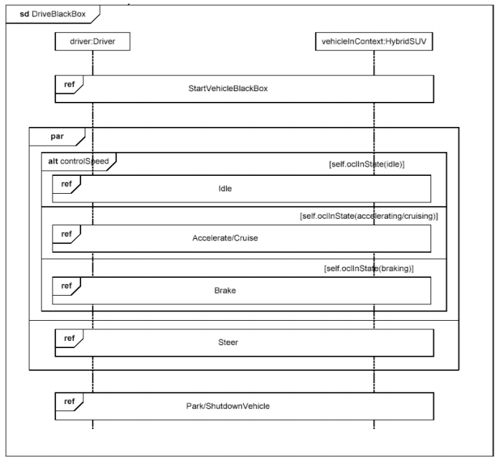

Object Management Group. "OMG Systems Modeling Language (OMG SysML) Hybrid SUV Non-Normative Example." November 2010 <<http://www.omg.org/ocsmp/HSUV.pdf>>

Below is a sequence diagram for the start vehicle interaction that was referenced in the operate vehicle sequence diagram above. The driver requests the vehicle to start, and the electrical power controller responds with the "ready" reply.

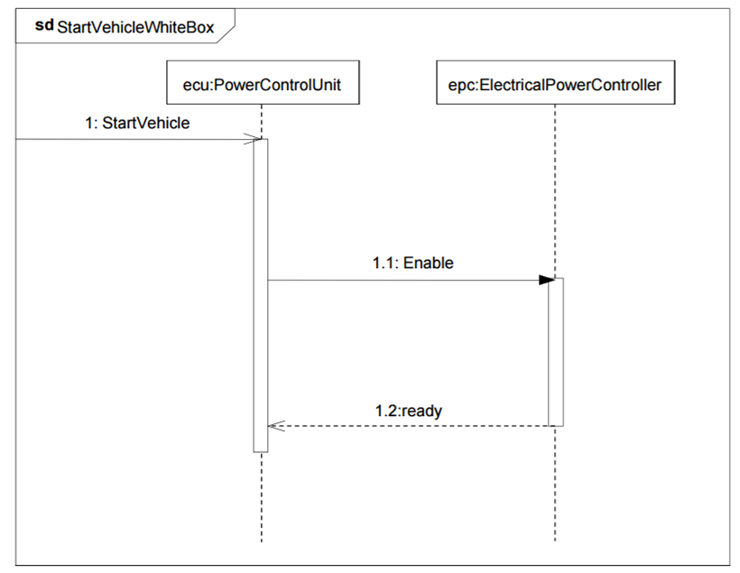

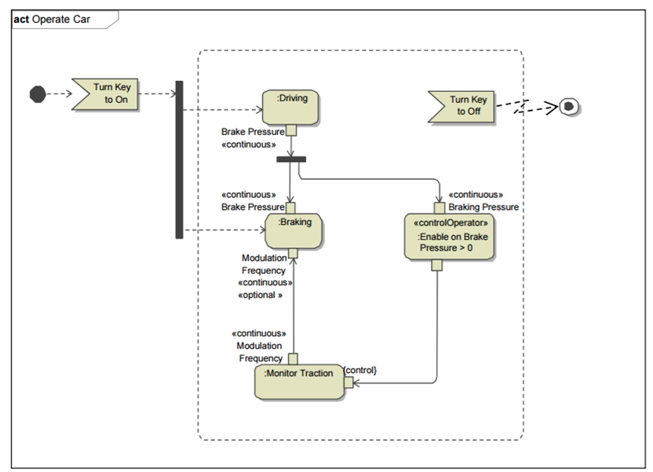

Sanford Friedenthal, Alan Moore and Rick Steiner. "OMG Systems Modeling Language Tutorial." 15 April 2008 <<http://www.omgsysml.org/INCOSE-OMGSysML-Tutorial-Final-090901.pdf>>

# **State Machine Diagram**

Below is the state machine diagram for the operate vehicle states. This diagram shows the states of the vehicle, and the events that can trigger a transition between the states. Note that this state machine was developed in conjunction with the operate vehicle interaction shown earlier. Off, Idle, Accelerating, Braking are different states of the vehicle. This diagram expresses only the nominal states. Exception states (e.g. accelerator failure) are not included in this diagram.

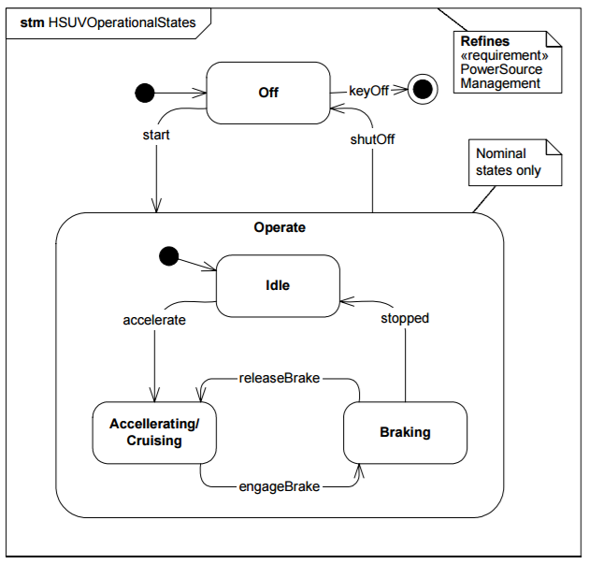

Object Management Group. "OMG Systems Modeling Language (OMG SysML) Hybrid SUV Non-Normative Example." November 2010 <<http://www.omg.org/ocsmp/HSUV.pdf>>

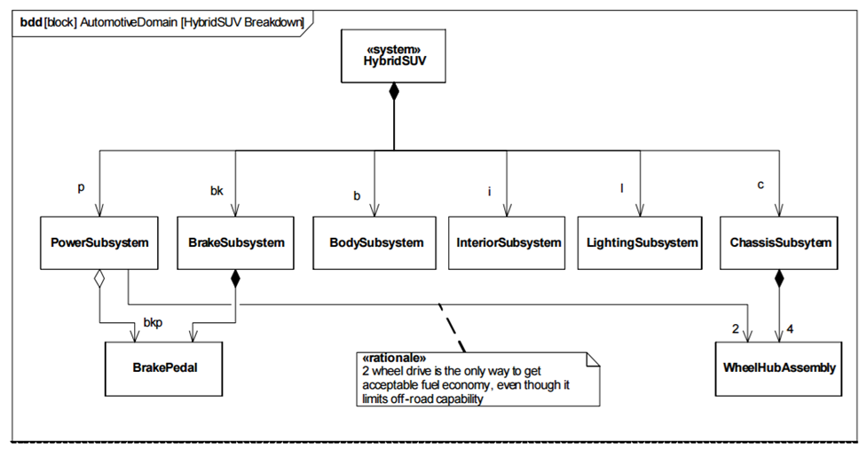

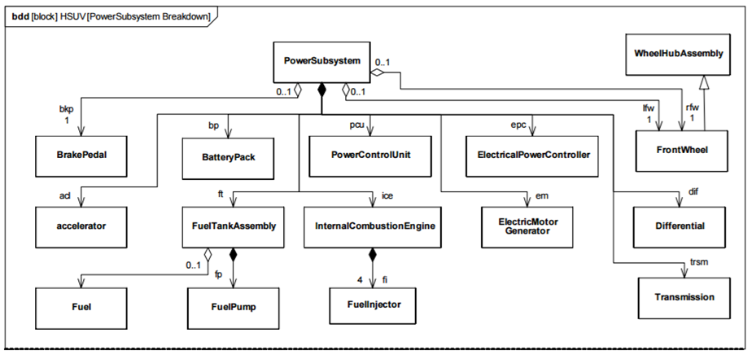

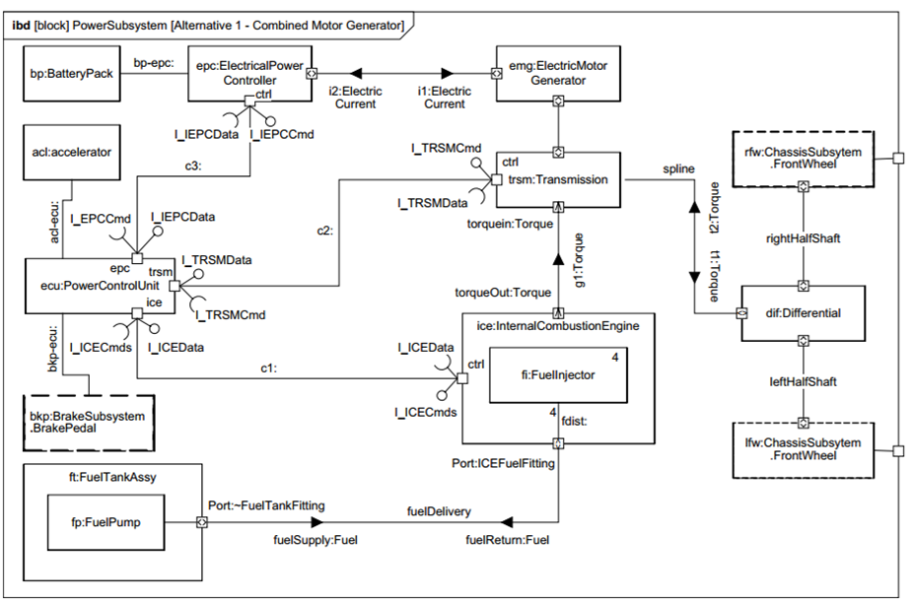

Object Management Group. "OMG Systems Modeling Language (OMG SysML) Hybrid SUV Non-Normative Example." November 2010 <<http://www.omg.org/ocsmp/HSUV.pdf>>

You can see the use of ports in the above diagram. To reiterate, port notation is given below:

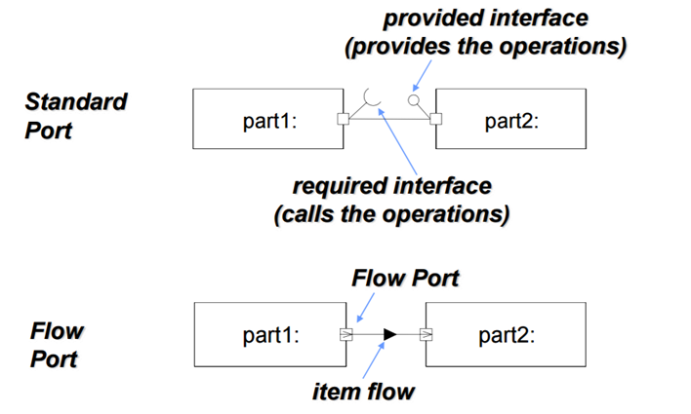  
**Sanford Friedenthal, Alan Moore and Rick Steiner. "OMG Systems Modeling Language Tutorial." 15 April 2008 <**<http://www.omgsysml.org/INCOSE-OMGSysML-Tutorial-Final-090901.pdf>**>**

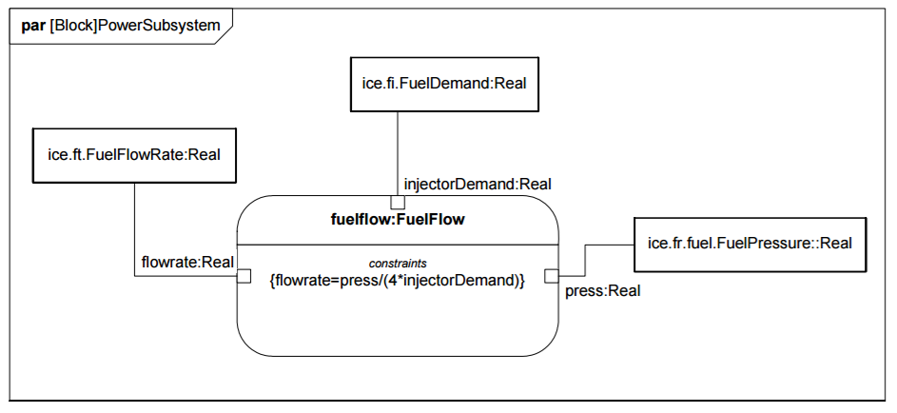

**Summary**

The examples above should give you a preliminary overview of SysML in action. Do not worry if you didn’t follow every aspect of it. The objective at this point is for you to get a sense of all the diagrams of SysML. You will become a SysML expert when you start working on problems in your organization.

Package diagrams represent the organization of a model in terms of packages that contain model elements

Requirement diagrams represent text-based requirements and their relationship with other requirements, design elements, and test cases to support requirements traceability

Activity diagrams represent behavior in terms of the order in which actions execute, based on the availability of their inputs, outputs, and control; and how the actions transform the inputs to outputs

Sequence diagrams represent behavior in terms of a sequence of messages exchanged between systems, or between parts of systems

State machine diagrams represent behavior of an entity in terms of its transitions between states, triggered by events

Use case diagrams represent functionality in terms of how a system is used by external entities (i.e. actors) to accomplish a set of goals

Block definition diagrams represent structural elements called blocks, and their composition and classification

Internal block diagrams represents interconnection and interfaces between the parts of a block

Parametric diagrams represent constraints on property values, such as F = m * a, used to support engineering analysis

**SysML eg Uber**

**Package 0 Use Cases**

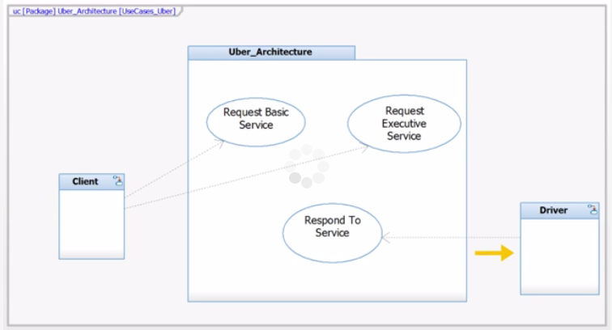

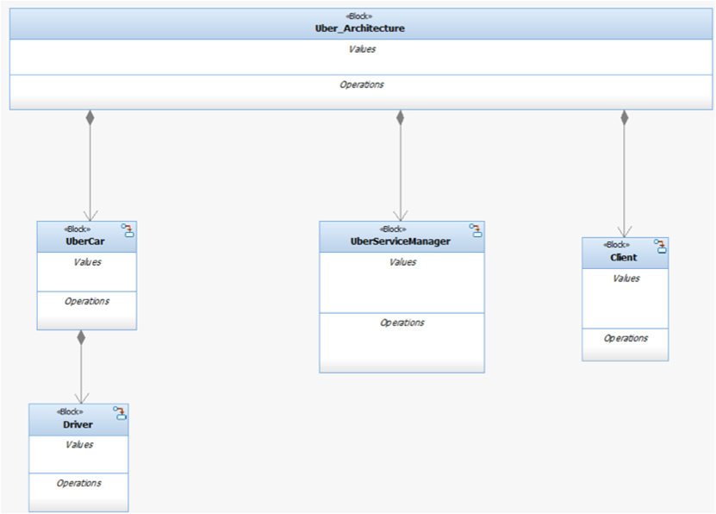

Block diagram with composition relationships correct

High level system digrams

Architectures

Car

Service manager

Client

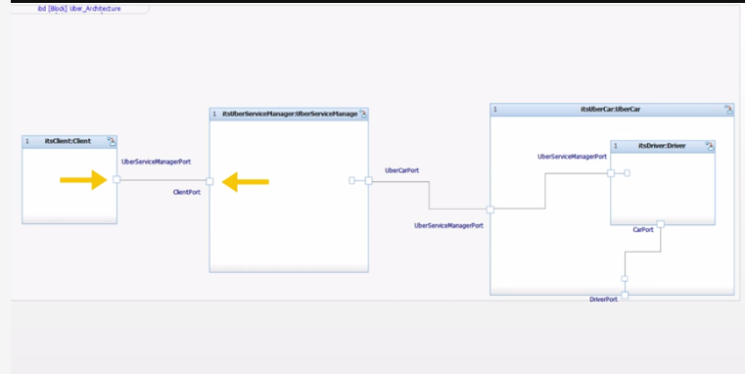

Client talking to service manager

Connected through ports

Car decomposed into various drivers

Composition is a special type of:

Aggregation correct

Explanation

Composition is a type of aggregation. By contrast, generalization crosses abstraction layers, and inheritance refers to features of the system across layers.

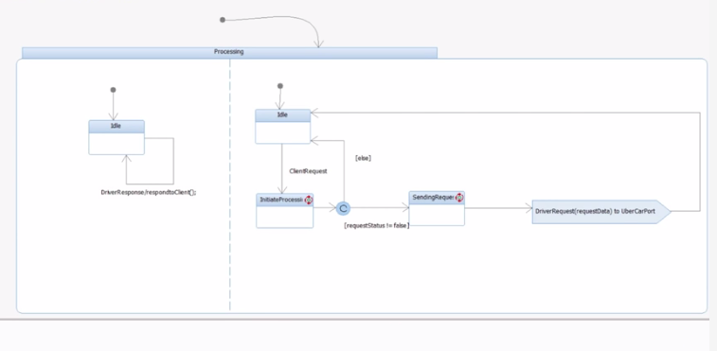

Behavior

State chart

Client receives/sends data

Uber service manager can get get data from client and driver

# Model Evaluation

Not correct by inspection or by virtue many people worked on the model

# Week 1 Key takeaways – benefits

**MBSE Benefits**

In traditional systems approaches, documents are the highest source of information concerning the requirements, constraints, architecture, designs, decisions, and other information about the system. But documents can become outdated, disconnected, or even contradictory. Model-based systems engineering (MBSE) provides several advantages over document-based engineering, including:

* + - Streamlined communication and sharing of information
    - Simpler change management
    - Increased traceability

Data modeling is an important aspect of MBSE that captures the requirement text, parent-child relationships, and related information such as owner, validity status, and other factors. The data constructs are:

* + - **Objects:** Objects represent concrete and conceptual things important to a business.
    - **Attributes (Properties):** Attributes are aspects of an object that define or describe an object.
    - **Relationships:** Establishes the relationship between entities (Composition, Aggregation, Directed Association, Generalization).
    - **Cardinality:** This is another important aspect of data modeling. Cardinality quantifies the relationships between entities by measuring how many instances of one entity are connected to a single instance of another.

**SysML**

The Systems Modeling Language (SysML) is general purpose architecture modeling language for Systems Engineering applications.

* + - SysML supports the specification, analysis, design, verification, and validation of a broad range of systems and systems-of-systems. These systems may include hardware, software, information, processes, personnel, and facilities.
    - SysML is a dialect of UML and is defined as a UML 2 Profile. (Profile = UML customization that uses Stereotypes, Tagged Values, and Constraints.)
    - SysML is an enabling technology for Model-Based Systems Engineering (MBSE).

SysML language includes the following nine diagram types that are used to model system concepts and architectures:

Week 2: Building an MBSE Model > SysML as an Example Language for MBSE > SysML Diagram Overview



# Week 2: Building an MBSE Model > Models as Data Repositories > Data Modeling Constructs

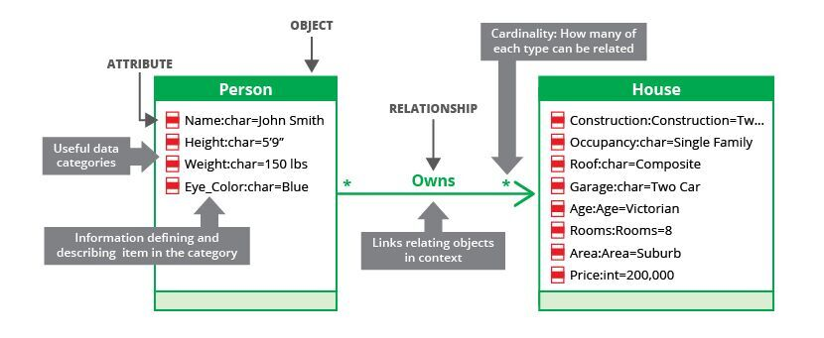

Week 2: Building an MBSE Model > SysML as an Example Language for MBSE > Overview of SysML

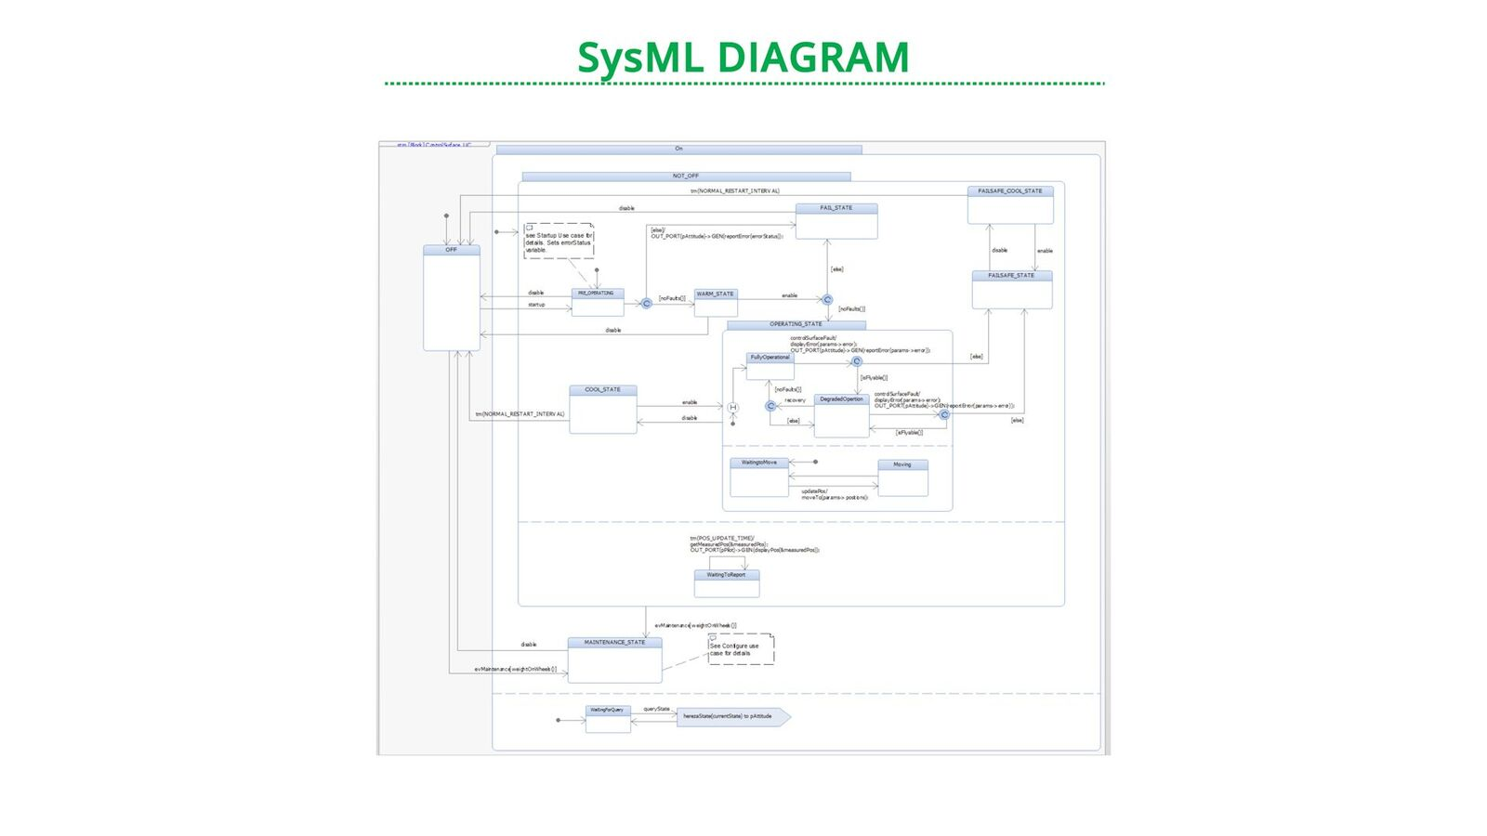

Week 2: Building an MBSE Model > Modeling Behavior and Structure with SysML > Modeling Behavior: Activity and Use

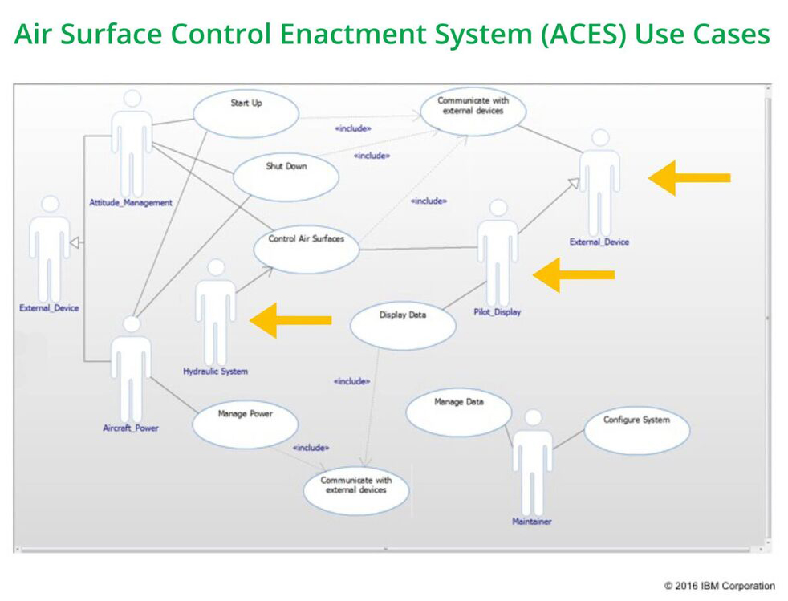

# Week 3 takeaways

**MBSE Challenges**

MBSE not only requires technical system information to be included in the common model, but also requires infrastructure, processes, and management effort. Some potential challenges to be aware of in the process of conducting a critique include:

* + - Integrating legacy products and models into the MBSE model
    - Quantity of data to be handled by the model
    - Upfront investment to design, develop, and implement an MBSE approach
    - Building a cadre of employees with modeling and software skills
    - Process definition and adoption by the different multidisciplinary teams
    - Team training on MBSE processes and tools

**Reasons for Conducting an MBSE Critique**

* + - Verify and validate the model for a given project, potentially as part of a non-advocate review
    - Evaluate the current state and achievements on an MBSE effort to determine whether it requires or would benefit from additional funding
    - Evaluate whether a sister project should adopt the MBSE approach based on the current MBSE efforts
    - Evaluate a tool vendor

**Structured Process for Exploring the Model During a Critique**

* + 1. Functionality and Use Cases
    2. Structure of the Model
    3. Interfaces
    4. Dependability and Failure Modes
    5. Concurrency Analysis
    6. Management and Deployment
    7. Review Against Qualities of Great Models

**Output of the Critique**

* + - Remark on whether the model is meetings the intended scope and purpose.
    - Set of observations and data on the model’s strengths and weaknesses. Your findings should relate back to specific instances of the model with data sampling to backup your feedback.
    - An evaluation against each of the qualities of great models, as well as supplementary behaviors or qualities you believe is relevant for an MBSE model.
    - Conclusions and recommendations for the specific rationale for the critique.

Week 3: Critiquing an MBSE Approach > Implementation Challenges of MBSE > Case Study: Boeing 787 Wiring

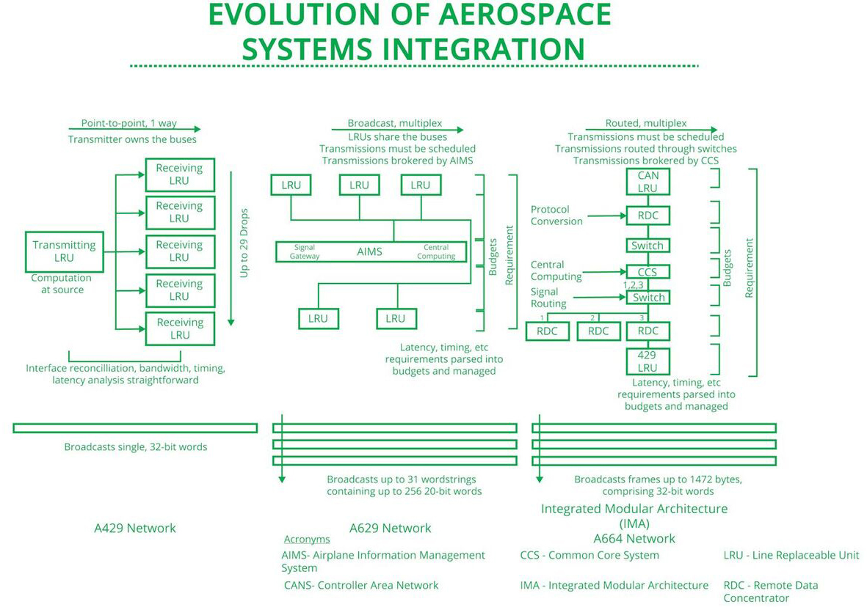Week 3: Critiquing an MBSE Approach > Implementation Challenges of MBSE > Challenges in MBSE 1

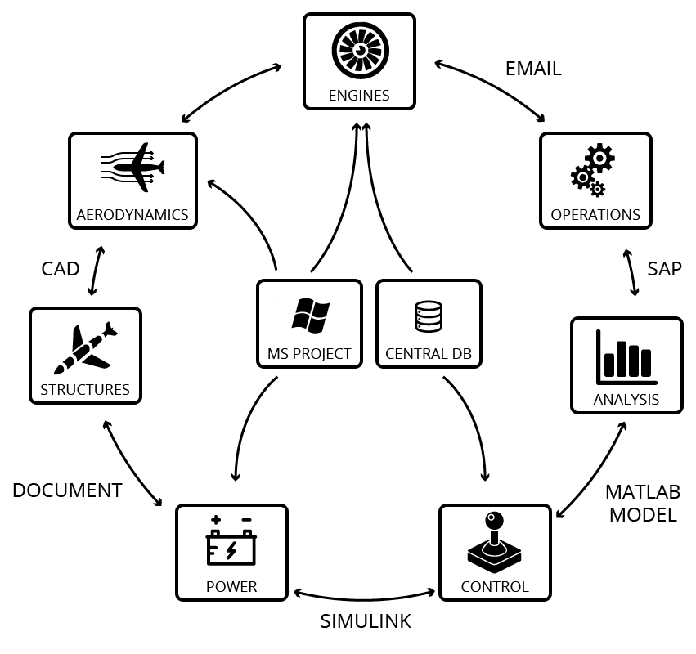

As projects grow in both complexity and scope, integration across teams and components becomes a major challenge in the product development cycle. The next image represents an MBSE approach.

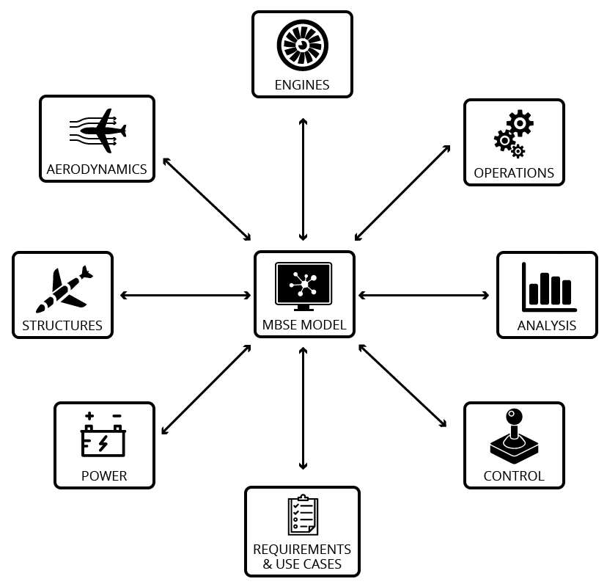

Week 3: Critiquing an MBSE Approach > Implementation Challenges of MBSE > Challenges in MBSE2

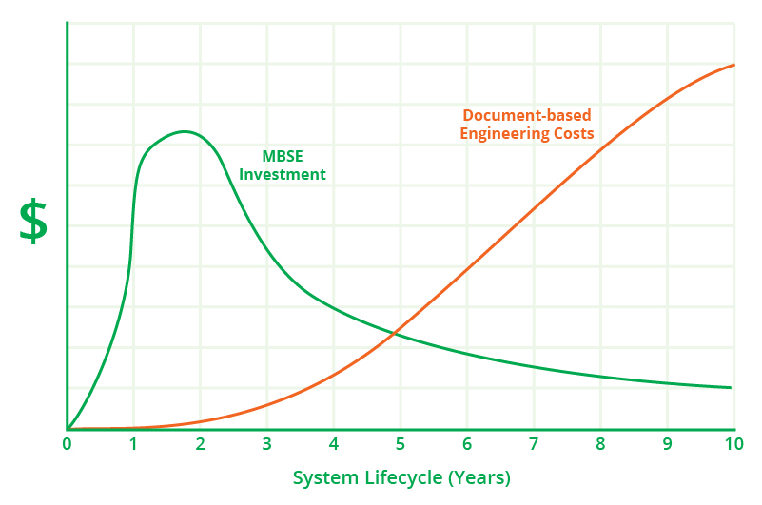

Week 3: Critiquing an MBSE Approach > Implementation Challenges of MBSE > Challenges in MBSE3

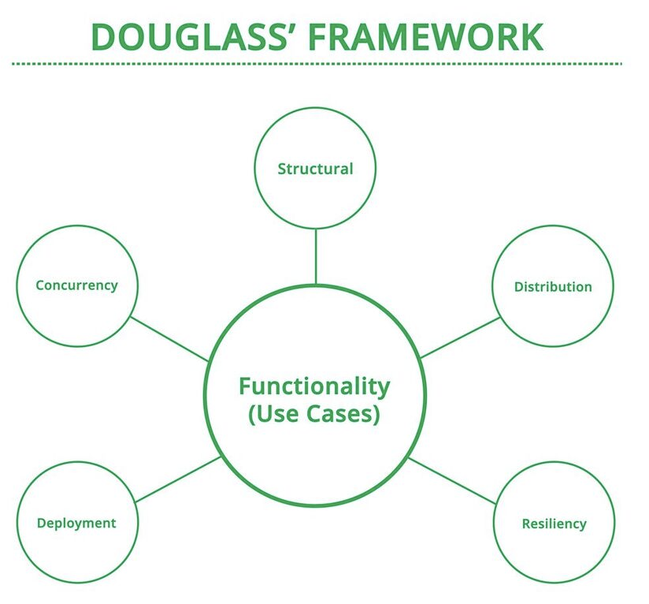

# Boeing aircraft wiring system

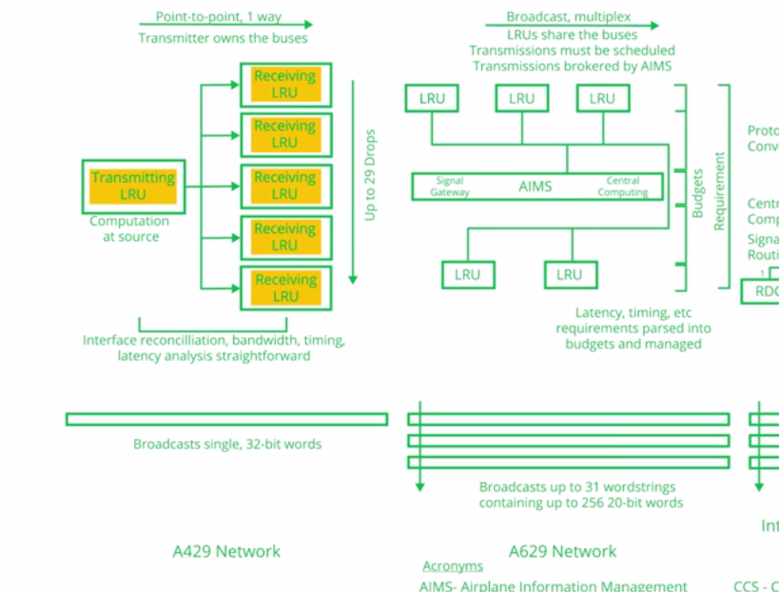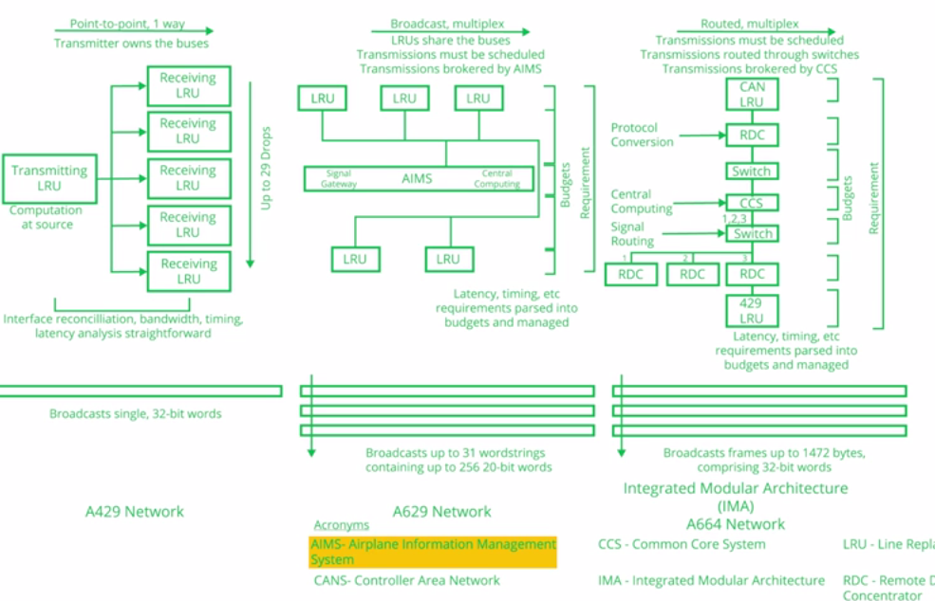

Typical systems queries

1. What is the overall bandwidth demanded of the network
2. What is the timing or performance of the system
3. Are they any functions that are not allocated to systems
4. Any systems that do not perform any of the required functions
5. 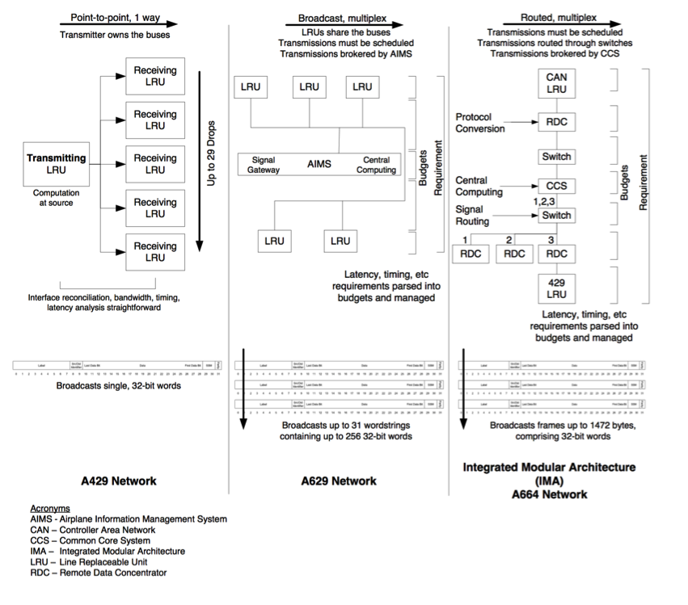

# MBSE vs no MBSE





# Implement the same requirement

# MSBE Qualification

Systems engineer

Standard language of SML

Tool

Ability to design domain specfici language

# **MBSE Challenges**

MBSE not only requires technical system information to be included in the common model, but also requires infrastructure, processes, and management effort. Some potential challenges to be aware  of in the process of conducting a critique include:

* + - Integrating legacy products and models into the MBSE model
    - Quantity of data to be handled by the model
    - Upfront investment to design, develop and implement an MBSE approach
    - Building a cadre of employees with modeling and software skills
    - Process definition and adoption by the different multidisciplinary teams
    - Team training on MBSE processes and tools

[Europa Mission’s Approach to MBSE](https://mitprofessionalx.mit.edu/assets/courseware/v1/0b776b1a6280124ec33bb079b0e28988/asset-v1:MITProfessionalX+SysEngx3+1T2017+type@asset+block/Europa_Background.pdf) (document by Alek Kerzhner and Brian Cooke of NASA-JPL

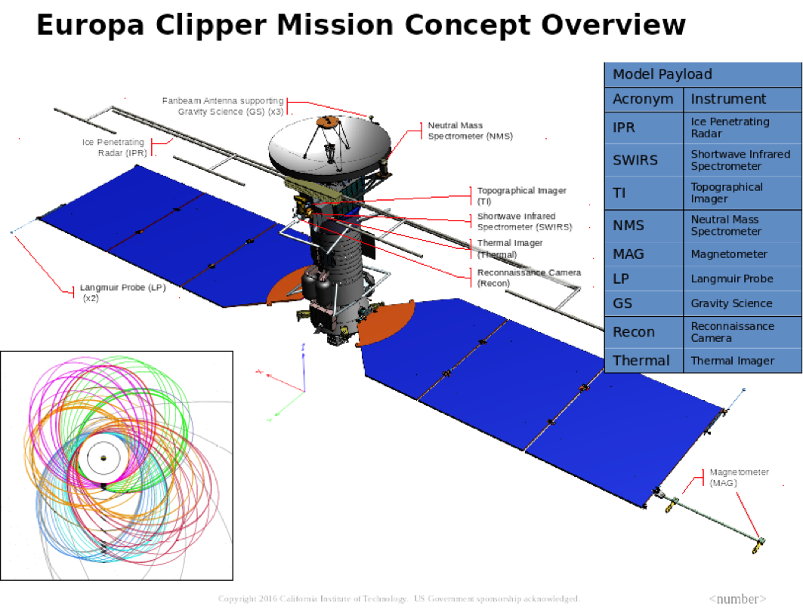

# Why critique MSBE

Purpose – mission critical, part of a companies competitive advantage

Benefits are challenging to quantify

Key – starting point, objectives

Challenges – getting to big

An **MBSE critique** is a critical review and assessment of the whole model with a defined rationale.

**Rationale for Performing an MBSE Critique**

An MBSE critique is a critical review and assessment of the whole model with a defined rationale. In an MBSE environment, this may or may not encompass several models across several disciplines. A critique is not a criticism, it is an analysis -- it is a positive approach to examining the qualities of the model.

Potential rationale of the critique include:

* + - Verify and validate the model for a given project, potentially as part of a non-advocate review.
    - Evaluate the current state and achievements on an MBSE effort to determine whether it requires or would benefit from additional funding.
    - Evaluate whether a sister project should adopt the MBSE approach based on the current MBSE efforts.
    - Evaluate a tool vendor.

A critique should result in a structured analysis of the limitations and strengths of the MBSE model(s).

MBSE critique can be considered a mechanism to provide feedback for improvement

# Manage a model over its lifecycle

Model owners

Decision rights:

Decision right to change the model

Right to input information

Who will Check model dynamics

Model curator – selects appropriate models for use

**Cognitive challenges**

**Automation bias**occurs when human operators in partially-automated systems rely excessively on automated solutions or processes without adequate monitoring and verification.

(Trusting automation too much

Complacency

A **mode error** is an error where a user mistakes the situation or mode they believe the program or machine to be in, and takes an action appropriate to the perceived mode, but inappropriate in the real mode. For example, editing what is believed to be a test version of the code, when in fact, the edits are making changes to published code.

**Perceptual challenges**

How well do we perform or think we perform.

**Model curation**

-synthesize information

- negotiation

Issues

Disconnect model

Wrong assumptions distrust,

over-trust,

data models,

unable to do sensitivity analysis

# PLM System

Model variants

Yellow=market requirements (choices take or not take)

Green = models (solution space – bill of materials

Portfolio of services

Product decomposition

Components=bottom layer

Product Information Model

# Model owner

A **model owner** is the single point of reference for making decisions for the model. Typically the model owner is the one who understands the cost of building and configuring the model and also has authority to change the model.

And that assumes that your NBSC is recognized as your **authoritative source for your system** definition.

**Changing a model parameters,** I believe, should always go through your system architect and your modelers. The modelers should actually be the ones to change the parameters, only through a disciplined process that I refer to as baseline control.

# Lessons learned from MBSE

NASA

The following is drawn from NASA’s Jet Propulsion Laboratory, as a summary of lessons learned in implementing MBSE on past projects.

* + - Educate and train an initial cadre of modelers
    - Pair domain experts with early career hires
    - Establish an institutionally-supported modeling environment
    - Define modeling standards, enable collaborative modeling effort, build a reusable model repository; provide support to system model developers
    - Identify and build applications
    - Develop system models that have immediate benefits to project’s needs
    - Partner modelers with project’s system engineers to get early buy-in
    - Use the initial application to validate the reusable modeling environment
    - Build on grassroots efforts

[(Dave Nichols and Chi Lin. Integrated Model-Centric Engineering: The Application of MBSE at JPL Through the Lifecycle. INCOSE International Workshop, January 26, 2014.)](http://www.omgwiki.org/MBSE/lib/exe/fetch.php?media=mbse:06-iw14-mbse_workshop-application_of_mbse_at_jpl_through_the_lifecycle-nichols-lin-final.pdf)

* + - Culture change is hard
    - Evolution not revolution - make a link back to existing processes
    - Model only what you need at the time
    - Communication is the prime objective - all infrastructure must be supporting better communication as a top requirement

(Mitch Ingham, Steve Jenkins, Aleksandr Kerzhner. JPL's Integrated Model-Centric Engineering Initiative: Advancing the State of the Art and Practice of Aerospace Systems Engineering. MIT, May 11, 2016.)

Boeing

Upfront cost = years for return

Avoided cost

Formal systems engineering effort = need for MSBE

Model parts of existing for integration

# Patterns

Architect – scope systems model

Data description document

Information needs to understand

Where are we storing the data

Critique

* + - * How extensible
      * Usability – 20 clicks ? noooooo

Pattern

* + - * A component should
        1. Have
        2. Perform

Completeness check

Consistanecy check

**Using Patterns to Compress Models**

A pattern describes a family of similar systems. A specific model of one of those systems can be created by configuration or specialization of the pattern. The configurations table in the pic below illustrates an extract of key variable configuration data for different configurations of a single requirements/design pattern (Apple MacBook). Such tables are familiar in catalogs of products. This illustrates how patterns facilitate compression - imagine if we had to show all the variants via diagram/s or rewriting all the specifications for each variant.

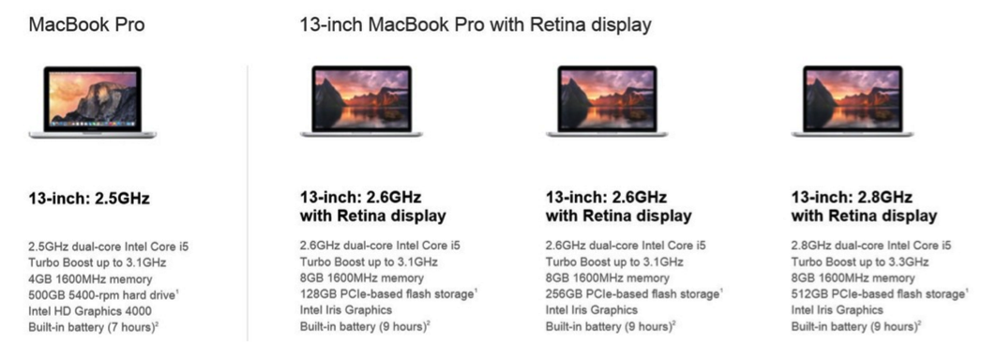

https://www.windowscentral.com/sites/wpcentral.com/files/styles/larger/public/field/image/2015/02/macbook-pro-pricing-screens.JPG?itok=TLQQK3Ym

Use of patterns in MBSE is driven by two overall processes:

● **Pattern Management Process**: Generates the underlying pattern, and periodically updates it based on application project discovery and learning

● **Pattern Configuration Process**: Configures the pattern into a specific model for application in a project

The patterns offer one-to-many cardinality, and families of patterns can be leveraged to compress the overall system depiction. Refer to the picture below for a pattern class hierarchy that may be used to depict different Chevrolet Corvette Models.

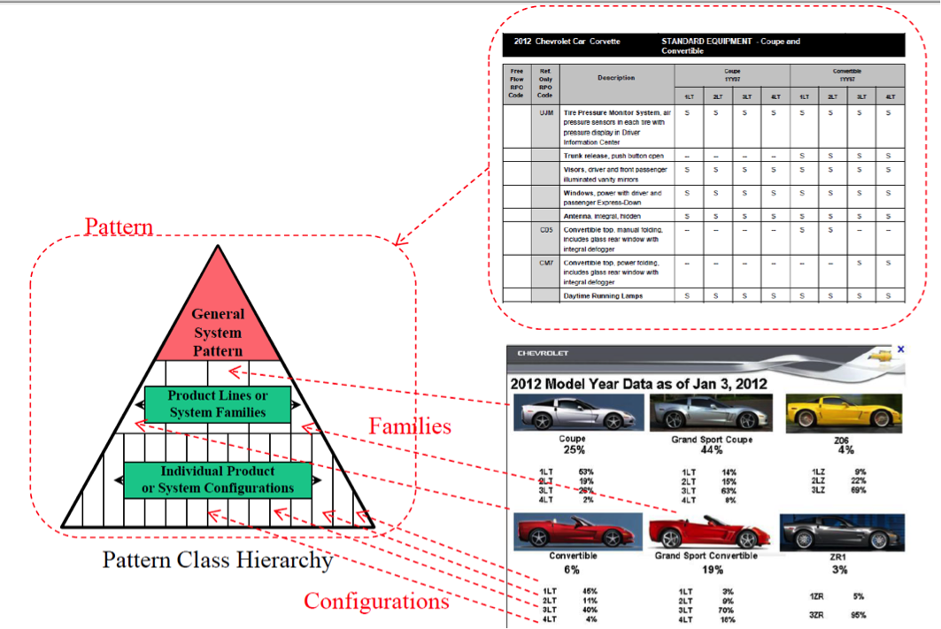

http://www.omgwiki.org/MBSE/lib/exe/fetch.php?media=mbse:05-iw14-mbse_workshop-an_application_of_model_based_system_patterns_to_consumer_packaged_products-berg-cpg.pdf

In summary, a pattern is a general-purpose abstraction of a system, which can be applied to a specific system. The patterns, therefore, provide the following benefits:

* + - They give the system engineers a selection of tried and tested solutions to work with
    - They are sometimes language neutral and if so can be applied to across many languages
    - They aid communication by being well documented and researched across previous projects
    - They have a proven track record and thus reduce the technical risk to the project
    - They are highly flexible and can be used in practically any type of application or domain

There are potential downsides of patterns as well.  They may take time to learn and may need substantial initial investment. Some of them can be difficult to grasp and comprehend. These are reasonable criticisms; however, when viewed over the lifetime of an application, one can reasonably expect those initial development costs to be recouped due to easier extensibility to meet new and emergent opportunities.

**References**

[MBSE Patterns Working Group (Patterns-Based Systems Engineering Challenge Team)](http://www.omgwiki.org/MBSE/doku.php?id=mbse:patterns:patterns)  
By: OMG Wiki  
  
[Pattern-Based Systems Engineering: Leveraging Model-Bsed Systems Engineering for Cyber-Physical Systems](http://ww2.esd.org/GVSETS/PDF/SE/SE_0905_SchindelBill_08042014_2200.pdf)  
By: Bill Schindel, ICTT System Sciences and Troy Peterson, Booz Allen Hamilton

# Model management plan

Which of the following are specifically called out as part of the model management plan? (Select all that apply.)

Initial Verification and Validation of the models correct

Defining the model owner correct

Funding the model correct

Process for model scope changes over the lifecycle correct

Model end of life and renewal planning correct

incorrect

# Review questions:

1. What are the advantages of the MBSE approach? (Select all that apply.)
   1. Reduces miscommunication spread due to outdated documents
   2. Reduces effort on tracking change propagation
2. MBSE enables all the stakeholders to access the information they need using views. However, different stakeholders may choose different views on the same information. That said, reusability of common viewpoints can enable comparisons of different systems by viewing through the same viewpoints.
3. Based on what was discussed in the video, documents are used in complex systems to:
   1. Gather requirements, maintain traceability to requirement source
   2. Manage master equipment list
   3. Provide details about the interface
   4. Create test scenarios
4. Traditionally, different documents are created to explain specific parts of the system, rather than having a single document that explains everything. This affords autonomy to different teams.
5. MBSE enables better information management by providing a single source of truth.
6. Which of the following are properties of a good model? (Select all that apply) – easily verifiable, complete, elegant
7. It is difficult to verify consistency in a document because inconsistent information may be separated by many pages - the reader may not recall the previous pages, and it may be difficult to surface the inconsistency.
8. It is hard to verify consistency of information in a document-based approach.
9. Which of the following are abstractions? (Select all that apply.)
   1. A requirements document
   2. An ordered list of project management tasks
   3. A system interface diagram
10. Which of the following are failure modes of modeling or poor modeling practices, based on the video above? (Select all that apply.)
    1. Trusting models blindly
    2. Modeling everything, leading to a proliferation of models
    3. Data tied together with rich relationships
    4. Modeling for the sake of modeling
    5. Non-executable models that can’t be checked
11. Multiple views make it easier for different stakeholders to consume information in the format they are most comfortable with.
12. It is always preferable to have a federation of models for an MBSE approach than a single central model rather than
13. Which of the following are MBSE methodologies used in practice? (Select all that apply.)
    1. Object Oriented Systems Engineering Methods (OOSEM)
    2. IBM Rational Unified Process for Systems Engineering (RUP SE)
14. Which of the following tasks are generally automated? (Select all that apply.)
    1. Simulating forces acting on the system
    2. Summing how many requirements have been met
15. What are some of the questions that should be asked when deciding on the scope an MBSE project? (Select all that apply.)
    1. What form or components will be captured by the MBSE model?
    2. Which system functions will be captured by the MBSE model?
16. What are some of the promises of the MBSE approach? (Select all that apply.)
    1. Reduces miscommunication amongst teams
    2. Makes testing and validation easier
    3. Enables easier reuse of system parts or components across projects correct
17. What are some of the tasks that could be improved by using MBSE?

Reduce risk by simplifying complexity

1. Which of the following are pitfalls associated with systems data captured in documents?
   1. Typically, these are independent documents with no relationships between the contents of different documents.
   2. Data cannot be shared across these deliverables and artifacts; one piece of information is bound to a single document; redundant information needs to be manually synchronized.
   3. Information in static documents cannot be queried and analyzed for errors and omissions.
   4. Static documents support only one viewpoint and the information cannot be recast for different perspectives.
   5. All of the above
2. Shifting to Model-Based Systems Engineering enables engineering teams to more readily understand design change impacts, communicate design intent and analyze a system design before it is built.
3. MBSE provides a mechanism for driving more rigor without increasing costs - False
4. Which type of diagram adds the dimension of time to object interactions? – sequence digrams

# Diagram Details:



|  |  |  |
| --- | --- | --- |
| **Diagram Type** | **Abbr.** | **Description** |
| [Activity Diagram](https://www.threesl.com/cradle/help/System%20Modelling/other/act.htm) | act | A SysML activity diagram is like a flowchart that describes the flow of control and data as the system executes its function. It is primarily used to define the behavior of a component  in terms of the time ordered sequence of actions to be executed based on the availability of inputs, outputs and control logic, and how the actions transform the inputs to outputs.  Expresses flow of action through the use-case  1) flow chart or  2) swim lane =use-case or component |
| [Block Definition Diagram](https://www.threesl.com/cradle/help/System%20Modelling/other/bdd.htm) | bdd | A SysML block definition diagram is the primary kind of diagram you create to communicate structural information about a system and shows component parts (i.e. blocks) that should exist in the system across different levels in hierarchy. It also depicts relevant properties and interfaces of each component part. |
| [Internal Block Diagram](https://www.threesl.com/cradle/help/System%20Modelling/other/ibd.htm) | ibd | A SysML internal block diagram describes the internal structure of a block, its properties, and connectors. It defines the interconnections of the block's component parts and the interactions (i.e. interface information) between the parts and between the parts and the systems outside the model boundary.  Block definition diagram – major block  Block = system or part of a system  Blocks = parts, behavior, relationships with other ports  Ports |
| [Package Diagram](https://www.threesl.com/cradle/help/System%20Modelling/other/pkg.htm) | pkg | A SysML package diagram allows you to organize models by partitioning model elements into packageable elements and establishing dependencies between packages, and/or model elements within packages. A package is like a container for anything else in the model. A hierarchy of packages can be defined. |
| [Parametric Diagram](https://www.threesl.com/cradle/help/System%20Modelling/other/par.htm) | par | A SysML parametric diagram illustrates system constraints such as one or more performance constraints, specifically equations and inequalities. It also supports engineering analyses, including performance, reliability, availability, power, mass, and cost. It can also be used to support trade studies of different system architectures.  Explain math relationships between parts of a systems  Each box is an equation or a variable in an equation  Parameters have types=units  ../../Desktop/Screen%20Shot%202017-07-02%20at%202.17.03%20 |
| [Requirement Diagram](https://www.threesl.com/cradle/help/System%20Modelling/other/req.htm) | req | A SysML requirement diagram is used to depict the requirements of the system. A graphical, tabular or tree structure format can be used to depict hierarchies of stakeholder needs, requirements and test cases or to depict an individual need/requirement/test case and its relationship to other model elements. |
| [Sequence Diagram](https://www.threesl.com/cradle/help/System%20Modelling/other/sd.htm) | sd | A SysML sequence diagram is used to specify the behavior of several interacting blocks in terms of a sequence of messages exchanged between those blocks. It shows how objects operate with one another and in what order (interactions arranged in time sequence). It can also be used to specify test cases.  ../../Desktop/Screen%20Shot%202017-07-02%20at%202.08.19%20 |
| [State Machine Diagram](https://www.threesl.com/cradle/help/System%20Modelling/other/stm.htm) | stm | A SysML state machine diagram is used to specify the behavior of a system in terms of its states and the transitions between states triggered by events and time. It shows a series of conditions which an object can take up over its lifespan, and the causes of the state changes.  States of operation or non-operation  State = set of (behaviors possible), pre-requisites, possible future states, possible sub states  Way to execute a model  ../../Desktop/Screen%20Shot%202017-07-02%20at%202.15.29%20../../Desktop/Screen%20Shot%202017-07-02%20at%202.16.54%20  ../../Desktop/Screen%20Shot%202017-07-02%20at%202.14.51%20  ../../Desktop/Screen%20Shot%202017-07-02%20at%202.13.31%20 |
| [Use Case Diagram](https://www.threesl.com/cradle/help/System%20Modelling/other/uc.htm) | uc | A SysML use case diagram is used to define operations in terms of how a system might be used by external entities (i.e. actors) to accomplish a set of goals/missions. Each use case is associated with a set of operational scenarios describing the desired activities to be performed. A scenario can be defined using an activity diagram. Use case diagrams are used to present a graphical overview of the functionality of a system.  System = rectangle  Ovals = use case (expressed as a verb phase)  Use-case = behavior  Design system based on that behavior  Ordered set of steps |



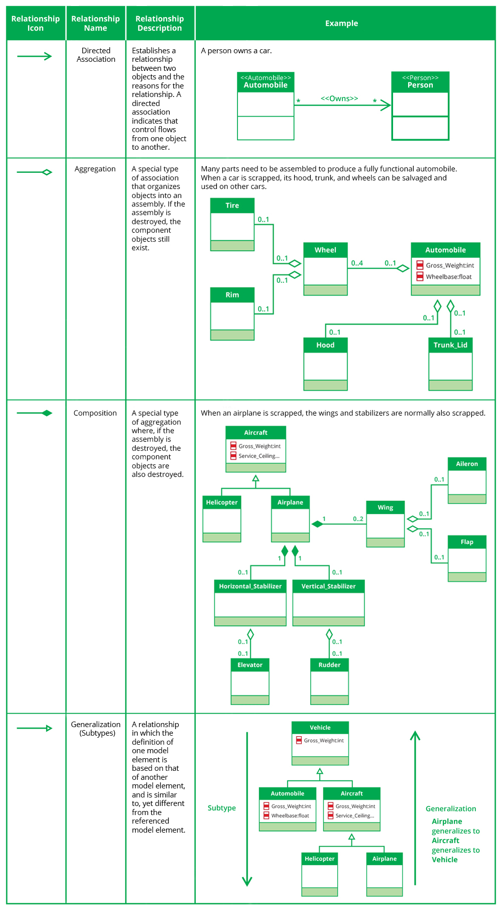





UseC

Goal/Yield

-max # of customers

-max number of homogeneous groups

Constraints

-15/15

- memory

Inputs

-120GB (2bn rows)

- demo file kb

- class file

Design

Data flow

1Get possible features

2Define class

3query data -->7 join aggr. 8Optimize yield w/constraints --> 9define class groups

4query data --> 5clean-> 6aggregate usage by cust 10filter cust by class->11a)aggregate by class

11b) ->new customer list -> aggregate demo

Outputs:

4xQual + 4xQuan=6 million X 600 features

Goal/Yield

-max # of customers

-max number of homogeneous groups

Goal/Yield

- enable renewable energy ->**customer choice** (self-generator, customer – clean or coal), prosumer

(? Coal)

- enable renewable benfits ->

- **distributed energy benefits** (less power loss, cheaper, cleaner, flexible load/generation)

- **distributed energy challenges** (intermittency, volatility, ramping, ability to control)

…. Through incentives

Constraints

- ability to monitor

- ability to control

- rate of adoption

- capacity, thermal and voltage

Inputs

- demand

- initial der by location

- adoption/forecast der by location and factors (incentives, etc.)

- price of energy and service from the bulk system

Design

Final dataflows

Outputs:

-Incentive based on size based on customer objective and type (residential, commercial)

-payments based on providing services

Goal/Yield

-Provide lower cost ancillary services through demand response

…. Through incentives

Constraints

Inputs

Usage

Segment customers – existing and targeted by customer

Disaggregated usage type by customer

Filtered

DR cost by customer

$/kW of DR type by customer (how to split the cost by usage type)

Aggregated usage type by node

Aggregated usage type by

Design

Final dataflows

Outputs: